Table of Contents
Page
Barriers to Fish Passage – Infrastructure 1-4
Barriers to Fish Passage – Tributary Confluences and Reservoir Pool Inlets 5-16
Barriers to Fish Passage – Natural Instream Barriers 17-28
Barriers to Fish Passage – Barriers Assessed from Low Altitude Helicopter Survey 29-38

Barriers to Fish Passage – Infrastructure

Barrier Characteristics

Barrier Identification | River Mile¹ | Location (UTM)² |  |  | Barrier  Class |  | Passable |  |  |  | Photograph
Barrier Identification | River Mile¹ | Easting | Northing |  |  |  | Trout |  | Minnows³ |  | Photograph
Middle Fork American River Downstream of Ralston Afterbay
Ralston Afterbay Dam | MF24.7 | 695141 |  | 4319549 |  | Falls |  | NO |  | NO | 1
Middle Fork American River from Ralston Afterbay to Middle Fork Interbay
Abandoned Weir below Middle Fork Interbay | MF35.5 | 707414 | 4322449 |  | Falls |  | NO |  | NA |  | 2
Middle Fork Interbay Dam | MF35.6 | 707538 | 4322404 |  | Falls |  | NO |  | NA |  | 3
Middle Fork American River Upstream of Middle Fork Interbay
Middle Fork American River Gage and Weir below French Meadows Dam | MF46.6 | 717789 | 4331977 |  | Falls |  | Potential |  | NA |  | 4
¹Abbreviation: MF = Middle Fork American River
²Universal Transverse Mercator Zone 10 North, North American Datum 1983
³Minnows include hardhead, Sacramento pikeminnow, and Sacramento sucker. Distribution was assumed to be limited to the Middle Fork American River downstream of Middle Fork Interbay and the
Rubicon River downstream of the impassable barrier at river mile 15.3

Barrier Photographs

1 | 2
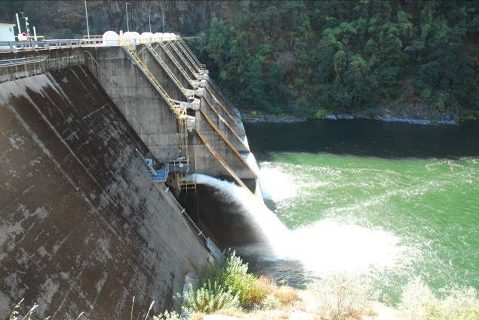 | 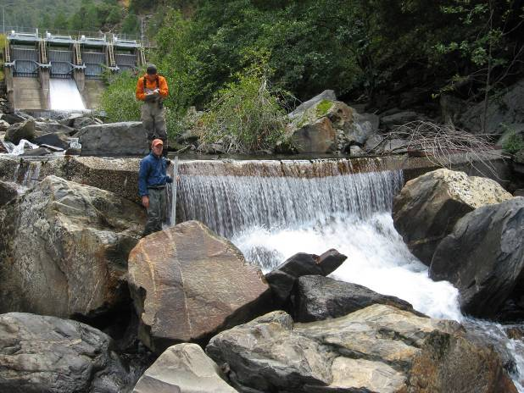
3 | 4
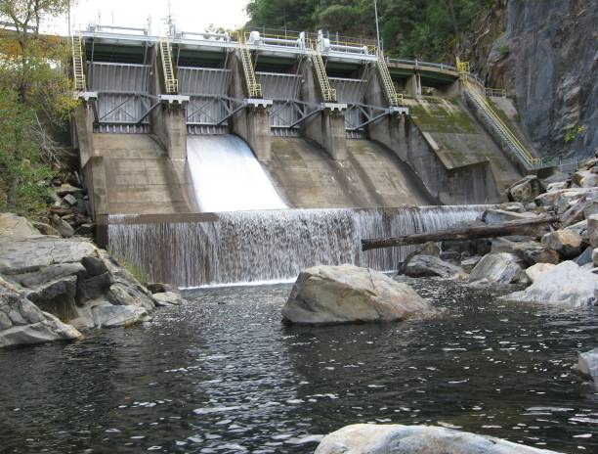 | 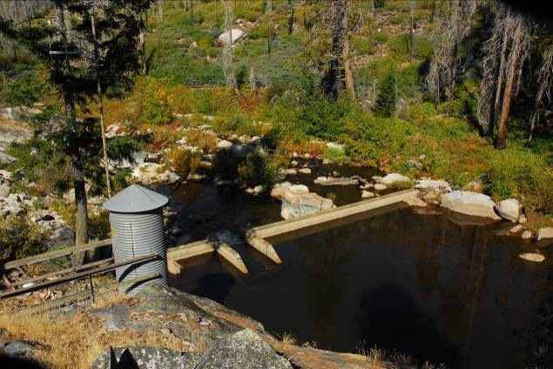

Barriers to Fish Passage – Infrastructure (continued)

Barrier Characteristics

Barrier Identification |  |  | River Mile¹ |  | Location (UTM)² |  |  |  |  |  |  | Barrier  Class |  | Passable |  |  |  |  | Photograph
 |  |  |  |  | Easting |  | Northing |  |  |  |  |  |  | Trout |  |  | Minnows³
Middle Fork American River Upstream of Middle Fork Interbay (continued)
French Meadows Dam | MF47.2 |  |  | 718733 |  |  |  |  | 4332190 |  | Falls |  | NO |  |  | NA |  |  |  | 5
Rubicon River
Hell Hole Dam |  |  | R30.5 |  | 724173 |  | 4326543 |  |  |  |  | Falls |  | NO |  |  | NA |  | 6
North Fork Long Canyon Creek
River Crossing of Hell Hole-Middle Fork Tunnel |  |  | NFLC0.6 |  | 715166 |  | 4322914 |  |  |  |  | Falls |  | NO |  |  | NA |  | 7
Cascade below weir below Diversion Dam - NFLC3.1 |  | NFLC3.1 |  |  |  | 717921 |  | 4325435 |  | Falls |  |  |  |  | NO |  |  | NA |  |  | 8
¹Abbreviation: MF = Middle Fork American River; R = Rubicon River; NFLC = North Fork Long Canyon Creek
²Universal Transverse Mercator Zone 10 North, North American Datum 1983
³Minnows include hardhead, Sacramento pikeminnow, and Sacramento sucker. Distribution was assumed to be limited to the Middle Fork American River downstream of Middle Fork Interbay
and the Rubicon River downstream of the impassable barrier at river mile 15.3

Barrier Photographs

5 | 6
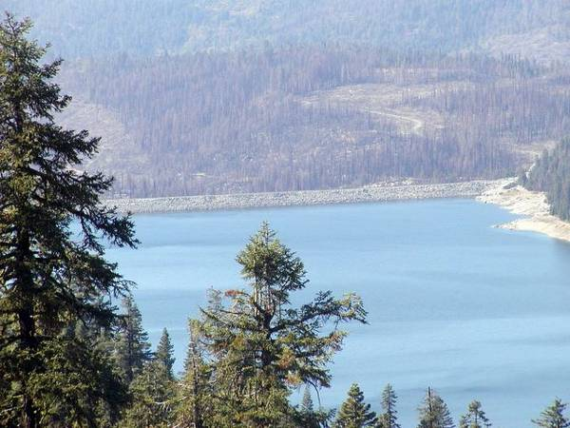 | 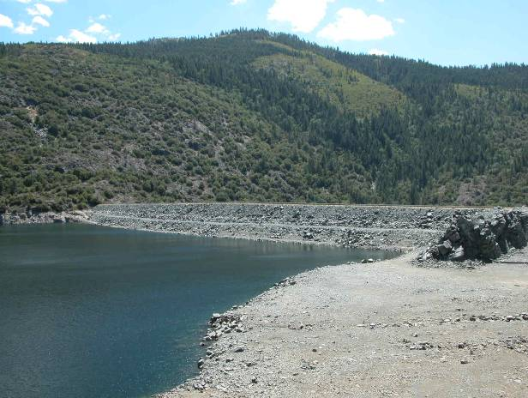
7 | 8
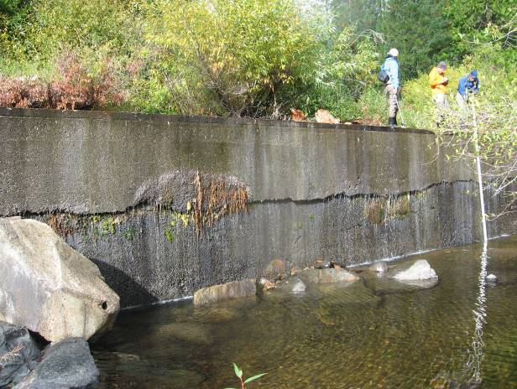 | 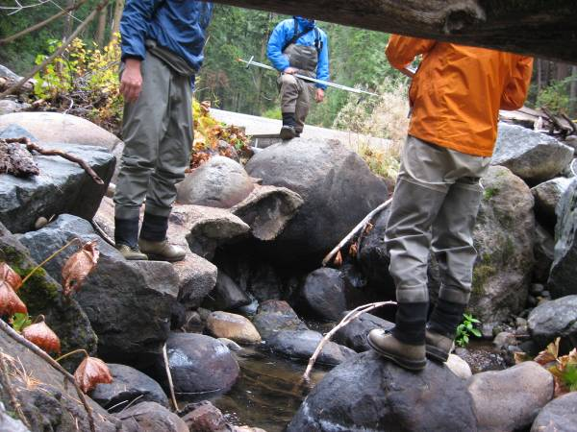

Barriers to Fish Passage – Infrastructure (continued)

Barrier Characteristics

Barrier Identification |  | River Mile¹ |  | Location (UTM)² |  |  | Barrier  Class |  | Passable |  |  |  |  | Photograph
 |  |  |  | Easting |  | Northing |  |  | Trout |  |  | Minnows³
North Fork Long Canyon Creek (continued)
North Fork Long Canyon Diversion Dam Weir | NFLC3.1 |  | 717921 |  | 4325435 |  |  | Falls |  | NO | NA |  | 9
North Fork Long Canyon Diversion Dam | NFLC3.1 |  | 717932 |  | 4325458 |  |  | Falls | NO |  | NA |  | 9
South Fork Long Canyon Creek
South Fork Long Canyon Diversion Dam | SFLC3.3 |  | 718874 |  | 4325511 |  |  | Falls | NO |  | NA |  | 10
14N28 Road Crossing to Middle Meadows Group Campground | SFLC3.5 |  | 719193 |  | 4325747 |  |  | Chute | NO |  | NA |  | 11
¹Abbreviation: NFLC = North Fork Long Canyon Creek, SFLC = South Fork Long Canyon Creek
²Universal Transverse Mercator Zone 10 North, North American Datum 1983
³Minnows include hardhead, Sacramento pikeminnow, and Sacramento sucker. Distribution was assumed to be limited to the Middle Fork American River downstream of Middle Fork
Interbay and the Rubicon River downstream of the impassable barrier at river mile 15.3

Barrier Photographs

9 | 10
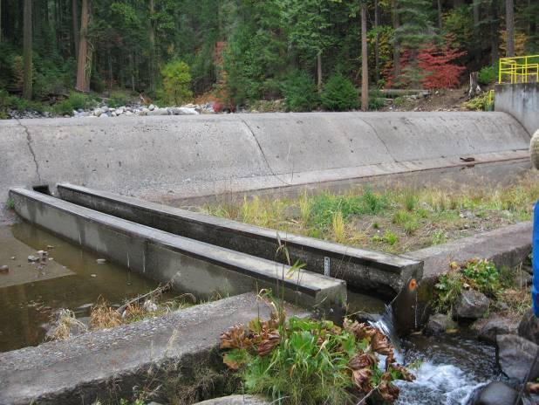  Dam  Weir | 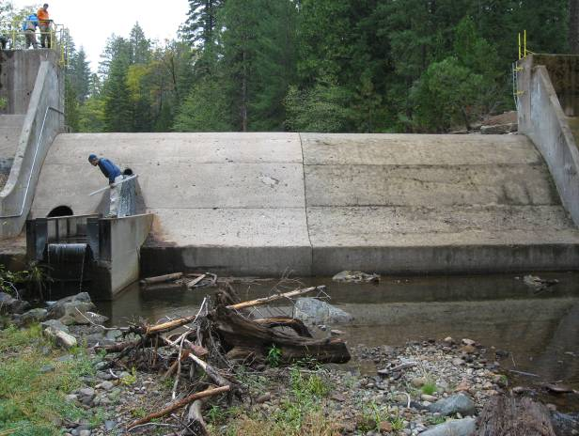
11
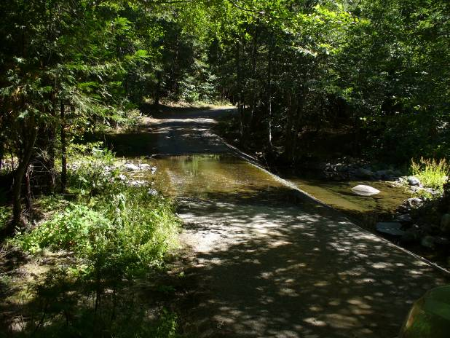
5’ high, steep angled drop

Barriers to Fish Passage – Infrastructure (continued)

Barrier Characteristics

Barrier Identification | River Mile¹ |  | Location (UTM)² |  |  |  | Barrier  Class |  | Passable |  |  |  |  | Photograph
Barrier Identification |  |  | Easting |  | Northing |  |  |  | Trout |  | Minnows³ |  |  | Photograph
Duncan Creek
Duncan Diversion Dam |  | D8.6 |  | 717696 |  | 4334707 |  | Falls |  | NO |  | NA | 13
Duncan Creek Gage and Weir above Diversion Dam |  | D8.8 |  | 717873 |  | 4334888 |  | Falls |  | Potential |  | NA | 14
¹Abbreviation:, D=Duncan Creek
²Universal Transverse Mercator Zone 10 North, North American Datum 1983
³Minnows include hardhead, Sacramento pikeminnow, and Sacramento sucker. Distribution was assumed to be limited to the Middle Fork American River downstream of Middle Fork
Interbay and the Rubicon River downstream of the impassable barrier at river mile 15.3

Barrier Photographs

13 | 14
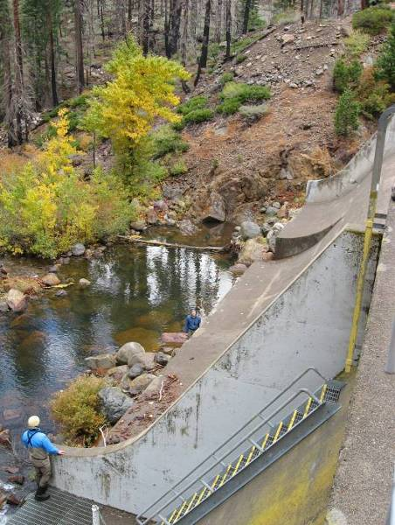 | 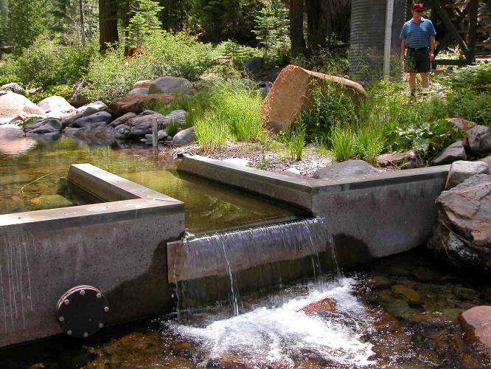

Barriers to Fish Passage – Tributary Confluences and Reservoir Pool Inlets

Barrier Characteristics

Barrier Identification | River Mile¹ |  | Location (UTM)² |  |  |  | Barrier  Class |  | Passable |  |  |  | Photograph
Barrier Identification |  |  | Easting |  | Northing |  |  |  | Trout |  | Minnows³
Middle Fork American River Downstream of Ralston Afterbay
American Canyon Creek - MF6.4 |  | MF6.4 |  | 678262 |  | 4311638 |  | Falls |  | NO |  | NO |  | 1–2
¹Abbreviation:, MF = Middle Fork American River
²Universal Transverse Mercator Zone 10 North, North American Datum 1983
³Minnows include hardhead, Sacramento pikeminnow, and Sacramento sucker. Distribution was assumed to be limited to the Middle Fork American River downstream of Middle Fork Interbay and
the Rubicon River downstream of the impassable barrier at river mile 15.3

Barrier Photographs

1 | 2
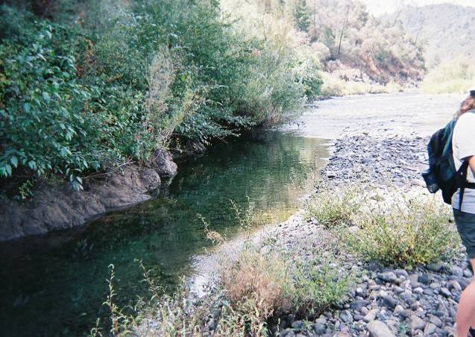  Middle Fork American River  American Canyon Creek | 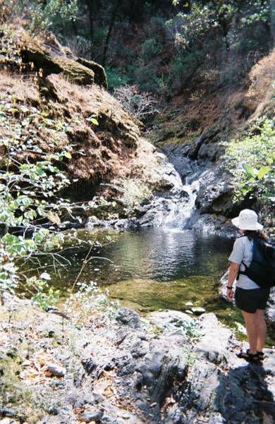

Barriers to Fish Passage – Tributary Confluences and Reservoir Pool Inlets (continued)

Barrier Characteristics

Barrier Identification | River Mile¹ |  |  |  | Location (UTM)² |  |  |  |  | Barrier  Class |  |  |  | Passable |  |  |  |  | Photograph
Barrier Identification |  |  |  |  | Easting |  |  | Northing |  |  |  |  |  | Trout |  | Minnows³
Middle Fork American River Downstream of Ralston Afterbay (continued)
Gas Canyon Creek - MF9.0a⁴ |  |  | MF9.0 |  |  | 679108 |  |  | 4314829 |  |  | Falls |  |  | NO |  |  | NO |  |  | 3
Gas Canyon Creek - MF9.0b⁴ |  |  | MF9.0 |  |  | 679108 |  |  | 4314829 |  |  | Falls |  |  | Potential |  |  | NO |  |  | 3
Gas Canyon Creek - MF9.0c |  | MF9.0 |  | 679108 |  |  | 4314829 |  |  |  | Falls |  | Potential |  |  |  | NO |  |  | 4
Todd Creek - MF9.6 |  | MF9.6 |  | 679855 |  |  | 4314604 |  |  |  | Falls |  | NO |  |  |  | NO |  |  | 5
Canyon Creek - MF11.0e |  | MF11.0 |  | 681803 |  |  | 4313651 |  |  |  | Critical Riffle |  | YES |  |  |  | YES |  |  | 6
¹Abbreviation: MF = Middle Fork American River
²Universal Transverse Mercator Zone 10 North, North American Datum 1983
³Minnows include hardhead, Sacramento pikeminnow, and Sacramento sucker. Distribution was assumed to be limited to the Middle Fork American River downstream of Middle
Fork Interbay and the Rubicon River downstream of the impassable barrier at river mile 15.3
⁴Barrier created by a non-Project general access road

Barrier Photographs

3 | 4
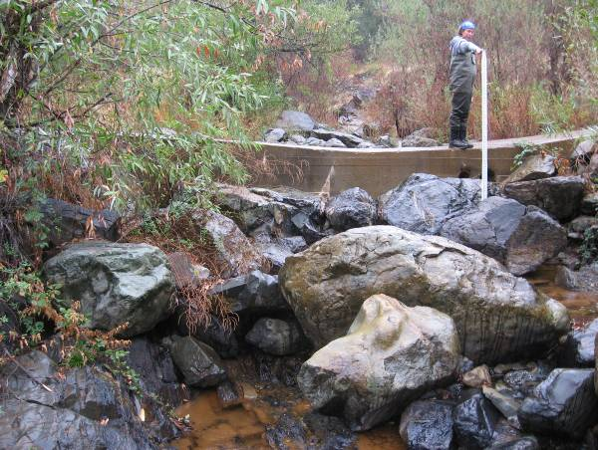 | 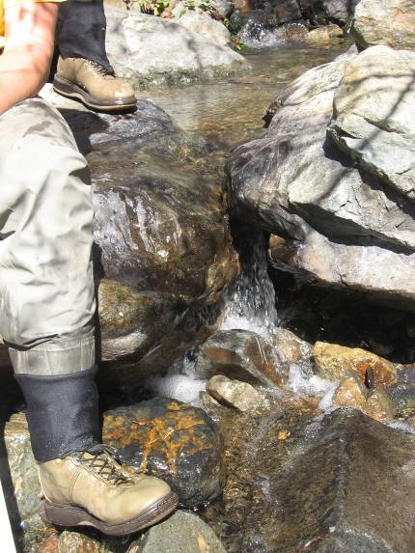
5 | 6
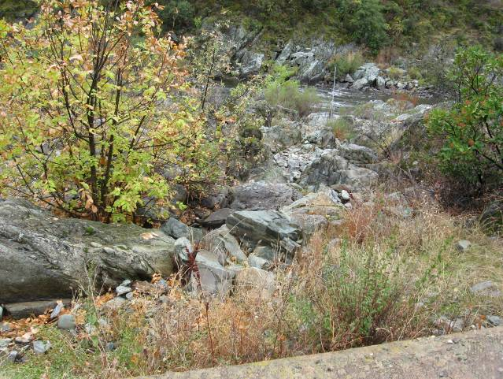  Middle Fork American River  Dry Todd Creek | 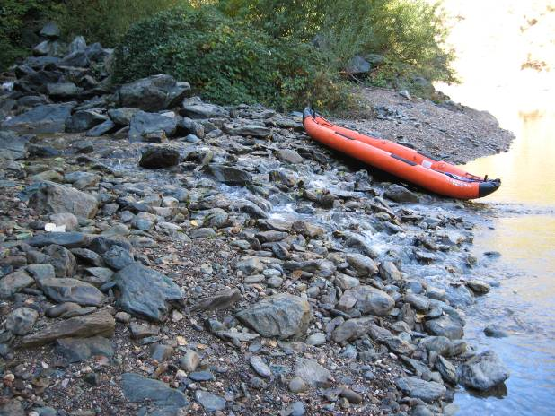

Barriers to Fish Passage – Tributary Confluences and Reservoir Pool Inlets (continued)

Barrier Characteristics

Barrier Identification | River Mile¹ | Location (UTM)² |  | Barrier  Class | Passable |  | Photograph
Barrier Identification | River Mile¹ | Easting | Northing | Barrier  Class | Trout | Minnows³ | Photograph
Middle Fork American River Downstream of Ralston Afterbay (continued)
Canyon Creek - MF11.0a | MF11.0 | 681803 | 4313651 | Falls | NO | NO | 7
Canyon Creek - MF11.0b | MF11.0 | 681803 | 4313651 | Chute | Potential | Potential | 7
Canyon Creek - MF11.0c | MF11.0 | 681803 | 4313651 | Falls | NO | NO | 7
Canyon Creek - MF11.0d | MF11.0 | 681803 | 4313651 | Chute | NO | NO | 7
Otter Creek - MF14.1 | MF14.1 | 685731 | 4314192 | Critical Riffle | YES⁴ | YES⁴ | 8
Otter Creek 1.5 miles upstream from confluence | OC1.5 | 685731 | 4314192 | Chute | NO | NO | No Photograph
Jesse Canyon Creek - MF17.0a | MF17.0 | 687760 | 4316253 | Chute | NO | NO | 9
Jesse Canyon Creek - MF17.0b | MF17.0 | 687760 | 4316253 | Falls | NO | NO | 10
¹Abbreviation: MF = Middle Fork American River, OC = Otter Creek
²Universal Transverse Mercator Zone 10 North, North American Datum 1983
³Minnows include hardhead, Sacramento pikeminnow, and Sacramento sucker. Distribution was assumed to be limited to the Middle Fork American River downstream of Middle Fork
Interbay and the Rubicon River downstream of the impassable barrier at river mile 15.3
⁴During surveys the critical riffle was passable, however during low flow periods the riffle may become impassable

Barrier Photographs

7 |  | 8
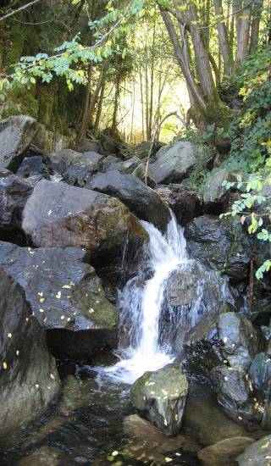 | 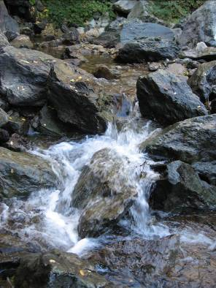 | 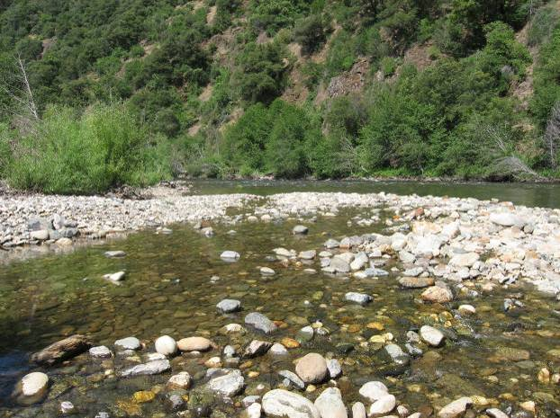
9 |  | 10
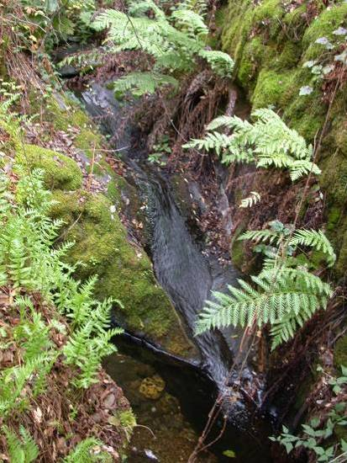 |  | 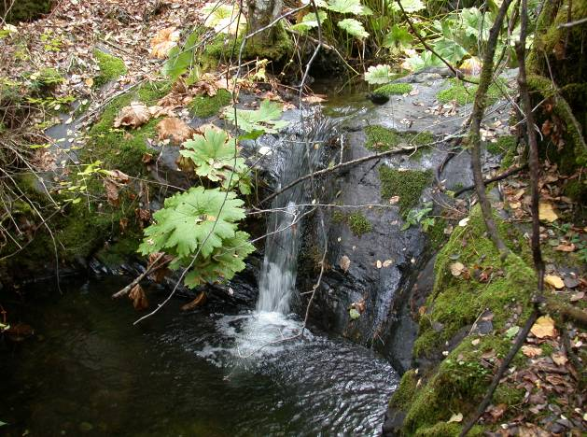

Barriers to Fish Passage – Tributary Confluences and Reservoir Pool Inlets (continued)

Barrier Characteristics

Barrier Identification | River Mile¹ | Location (UTM)² |  | Barrier  Class | Passable |  | Photograph
Barrier Identification | River Mile¹ | Easting | Northing | Barrier  Class | Trout | Minnows³ | Photograph
Middle Fork American River Downstream of Ralston Afterbay (continued)
Jesse Canyon Creek - MF17.0c | MF17.0 | 687760 | 4316253 | Chute | NO | NO | 11
Jesse Canyon Creek - MF17.0d | MF17.0 | 687760 | 4316253 | Chute | NO | NO | 12
Jesse Canyon Creek - MF17.0e | MF17.0 | 687760 | 4316253 | Falls | NO | NO | 13
Pond Creek - MF18.1 | MF18.1 | 688082 | 4317906 | Falls | NO | NO | 14
¹Abbreviation: MF = Middle Fork American River
²Universal Transverse Mercator Zone 10 North, North American Datum 1983
³Minnows include hardhead, Sacramento pikeminnow, and Sacramento sucker. Distribution was assumed to be limited to the Middle Fork American River downstream of
Middle Fork Interbay and the Rubicon River downstream of the impassable barrier at river mile 15.3

Barrier Photographs

11 | 12
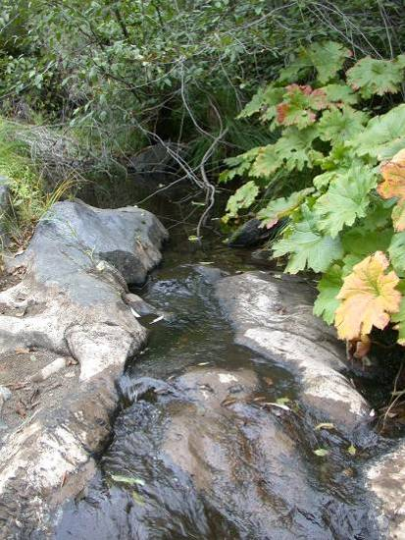 | 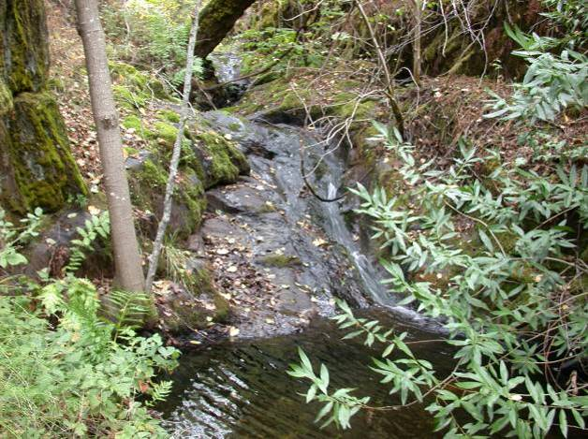
13 | 14
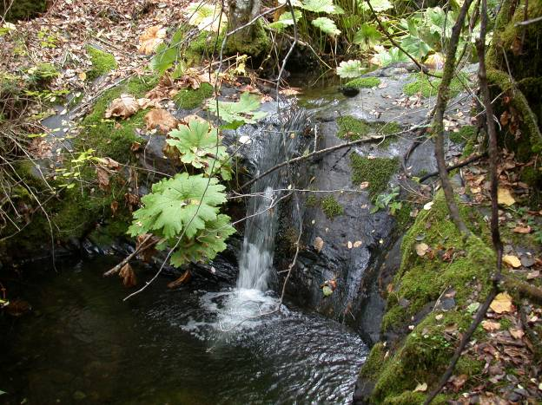 | 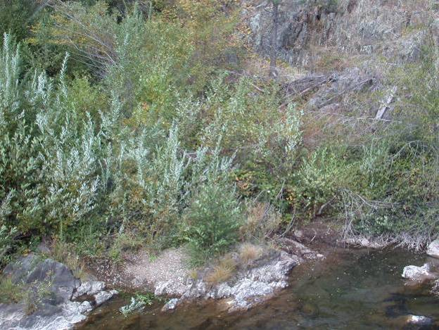

Barriers to Fish Passage – Tributary Confluences and Reservoir Pool Inlets (continued)

Barrier Characteristics

Barrier Identification | River Mile¹ | Location (UTM)² |  | Barrier  Class | Passable |  | Photograph
Barrier Identification | River Mile¹ | Easting | Northing | Barrier  Class | Trout | Minnows³ | Photograph
Middle Fork American River Downstream of Ralston Afterbay (continued)
Dardanelles Creek - MF18.5 | MF18.5 | 688488 | 4318285 | Falls | NO | NO | No Photograph
Snyder Canyon Creek - MF19.5 | MF19.5 | 689729 | 4319163 | Falls | NO | NO | No Photograph
Volcano Canyon Creek - MF20.9a | MF20.9 | 691477 | 4319094 | Falls | NO | NO | 15
Volcano Canyon Creek - MF20.9b | MF20.9 | 691477 | 4319094 | Falls | Potential | NO | 15
Volcano Canyon Creek - MF 20.9d | MF20.9 | 691477 | 4319094 | Falls | NO | NO | 16
Volcano Canyon Creek - MF20.9e | MF20.9 | 691477 | 4319094 | Chute | Potential | Potential | 17
Volcano Canyon Creek -MF20.9f | MF20.9 | 691477 | 4319094 | Falls | Potential | NO | 17
North Fork of the Middle Fork American River - MF24.1 | MF24.1 | 695149 | 4320344 | No Barrier | YES | YES | 18
¹Abbreviation: MF = Middle Fork American River
²Universal Transverse Mercator Zone 10 North, North American Datum 1983
³Minnows include hardhead, Sacramento pikeminnow, and Sacramento sucker. Distribution was assumed to be limited to the Middle Fork American River downstream of Middle
Fork Interbay and the Rubicon River downstream of the impassable barrier at river mile 15.3

Barrier Photographs

15 | 16
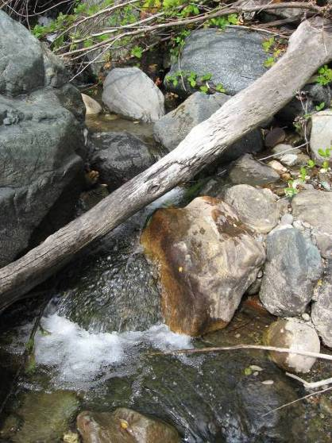 | 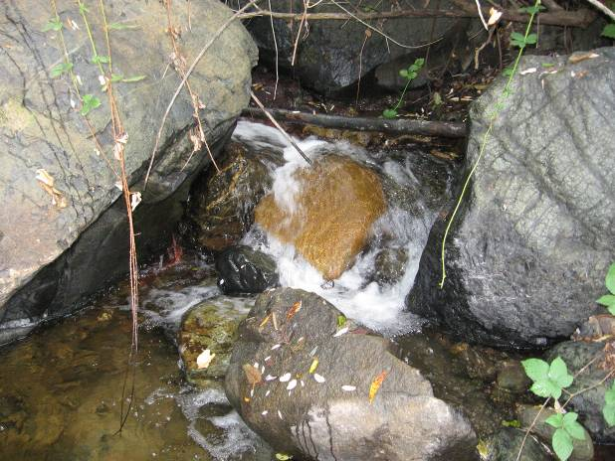  More chutes upstream
17 | 18
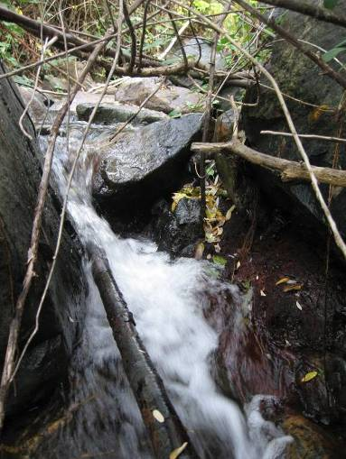 | 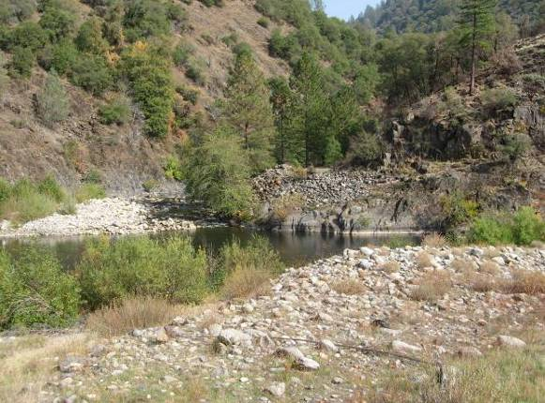

Barriers to Fish Passage – Tributary Confluences and Reservoir Pool Inlets (continued)

Barrier Characteristics

Barrier Identification | River Mile¹ | Location (UTM)² |  | Barrier  Class | Passable |  | Photograph
Barrier Identification | River Mile¹ | Easting | Northing | Barrier  Class | Trout | Minnows³ | Photograph
Middle Fork American River from Ralston Afterbay to Middle Fork Interbay
Ralston Afterbay - MF25.9 | MF25.9 | 696459 | 4319884 | No Barrier | YES | YES | 19
Brushy Canyon Creek - MF30.4 | MF30.4 | 702383 | 4321592 | Cascade | NO | NA | 20
Middle Fork American River Upstream of Middle Fork Interbay
Middle Fork Interbay - MF36.0 | MF36.0 | 708192 | 4322344 | No Barrier | YES | NA | 21
Duncan Creek - MF39.7a | MF39.7 | 712459 | 4323934 | Chute | Potential | NA | 22
¹Abbreviation: MF = Middle Fork American River
²Universal Transverse Mercator Zone 10 North, North American Datum 1983
³Minnows include hardhead, Sacramento pikeminnow, and Sacramento sucker. Distribution was assumed to be limited to the Middle Fork American River downstream of Middle
Fork Interbay and the Rubicon River downstream of the impassable barrier at river mile 15.3

Barrier Photographs

19 | 20
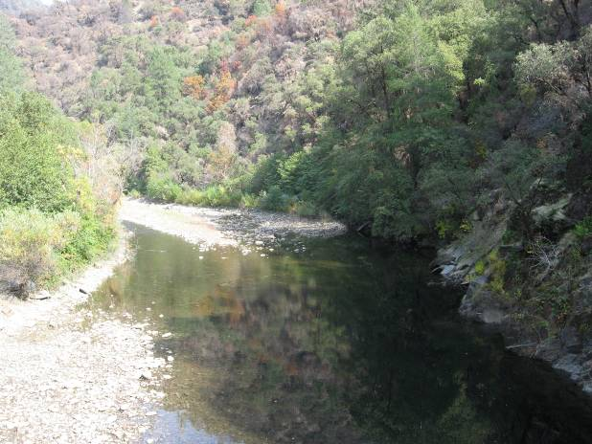  Middle Fork American River inflow to Ralston Afterbay | 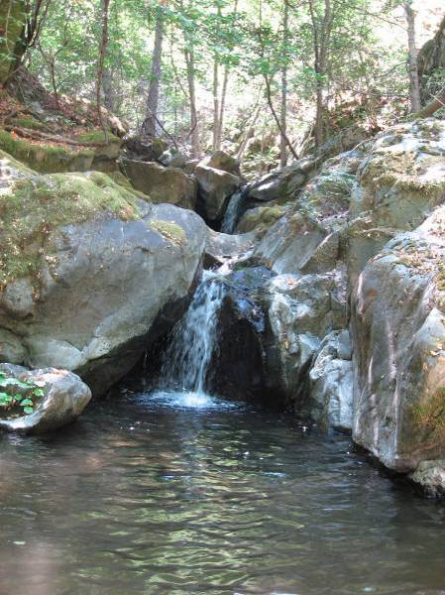
21 | 22
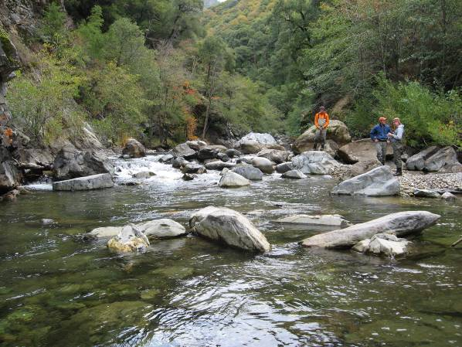  Middle Fork American River inflow to Middle Fork Interbay | 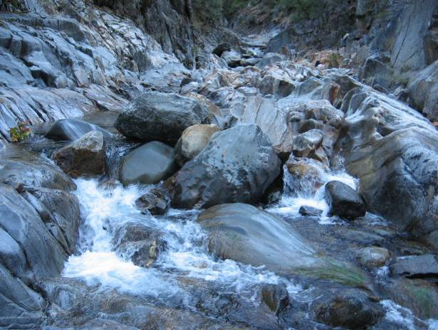

Barriers to Fish Passage – Tributary Confluences and Reservoir Pool Inlets (continued)

Barrier Characteristics

Barrier Identification | River Mile¹ | Location (UTM)² |  | Barrier  Class | Passable |  | Photograph
Barrier Identification | River Mile¹ | Easting | Northing | Barrier  Class | Trout | Minnows³ | Photograph
Middle Fork American River Upstream of Middle Fork Interbay (continued)
Duncan Creek - MF39.7b | D0.0 | 712459 | 4323934 | Falls | NO | NA | 23
French Meadows Reservoir | MF51.6 | 724039 | 4334659 | No Barrier | YES | NA | 24
Rubicon River
Ralston Afterbay | R0.7 | 697130 | 4319170 | No Barrier | YES | YES | No Photograph
Long Canyon Creek - R3.6a | R3.6 | 700400 | 4318437 | No Barrier | YES | YES | 25
Long Canyon Creek - R3.6b⁴ | LC0.2 | 700400 | 4318437 | Falls | NO | NO | 26
¹Abbreviation: D=Duncan Creek, MF = Middle Fork American River; R = Rubicon; LC = Long Canyon Creek
²Universal Transverse Mercator Zone 10 North, North American Datum 1983
³Minnows include hardhead, Sacramento pikeminnow, and Sacramento sucker. Distribution was assumed to be limited to the Middle Fork American River downstream of Middle Fork
Interbay and the Rubicon River downstream of the impassable barrier at river mile 15.3
⁴Barrier 0.2 miles upstream from confluence

Barrier Photographs

23 | 24
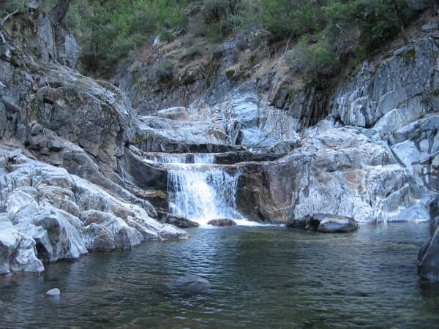 | 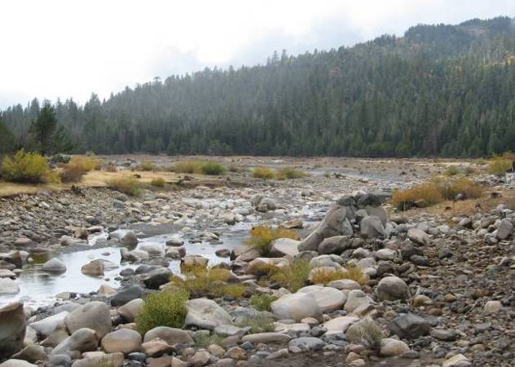  Middle Fork American River inflow to French Meadows Reservoir
25 | 26
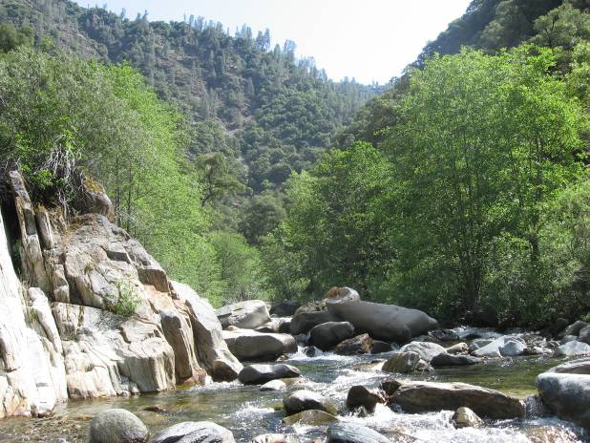  Long Canyon Creek inflow to Rubicon River | 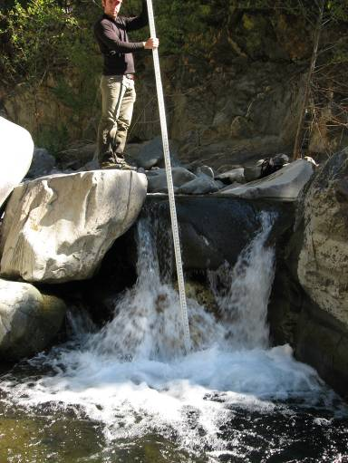

Barriers to Fish Passage – Tributary Confluences and Reservoir Pool Inlets (continued)

Barrier Characteristics

Barrier Identification | River Mile¹ | Location (UTM)² |  | Barrier  Class | Passable |  | Photograph
Barrier Identification | River Mile¹ | Easting | Northing | Barrier  Class | Trout | Minnows³ | Photograph
Rubicon River (continued)
Pilot Creek - R5.2a | R5.2 | 700746 | 4316083 | No Barrier | YES | YES | No Photograph
Pilot Creek - R5.2b | R5.2 | 700746 | 4316083 | Falls | Potential | NO | 27
Pilot Creek - R5.2c | R5.2 | 700746 | 4316083 | Falls | NO | NO | 27
Pilot Creek - R5.2d | R5.2 | 700746 | 4316083 | Falls | NO | NO | 28
Pilot Creek - R5.2e | R5.2 | 700746 | 4316083 | Chute | Potential | Potential | 28
Pilot Creek - R5.2f | R5.2 | 700746 | 4316083 | Falls | NO | NO | 28
South Fork Rubicon River - R22.6 | R22.6 | 719225 | 4316448 | Falls | NO | NA | 29
Hell Hole Reservoir Inlet - R34.5a | R34.5 | 727562 | 4329698 | Chute | YES | NA | 30
Hell Hole Reservoir Inlet - R34.5b | R34.5 | 727562 | 4329698 | Chute | YES | NA | 30
Hell Hole Reservoir Inlet - R34.5c | R34.5 | 727562 | 4329698 | Falls | NO | NA | 30
¹Abbreviation: R = Rubicon
²Universal Transverse Mercator Zone 10 North, North American Datum 1983
³Minnows include hardhead, Sacramento pikeminnow, and Sacramento sucker. Distribution was assumed to be limited to the Middle Fork American River downstream of Middle
Fork Interbay and the Rubicon River downstream of the impassable barrier at river mile 15.3

Barrier Photographs

27 | 28
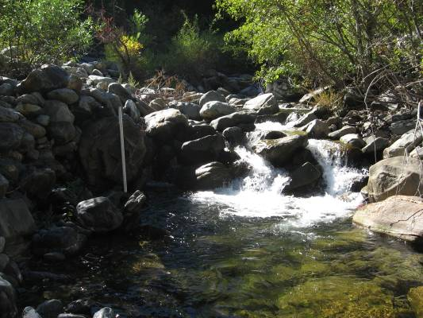 | 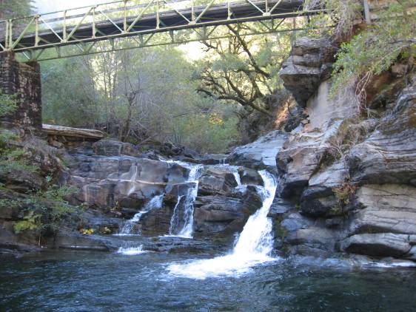
29 | 30
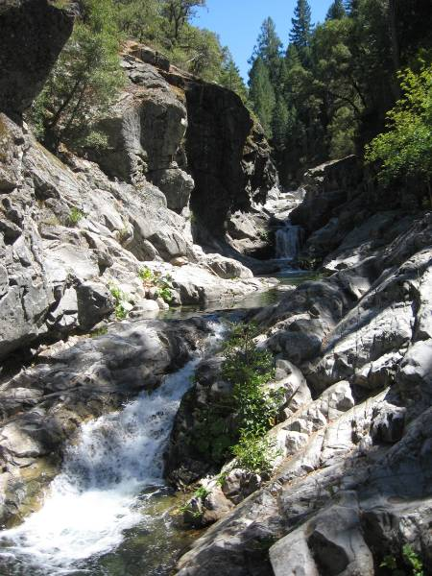 | 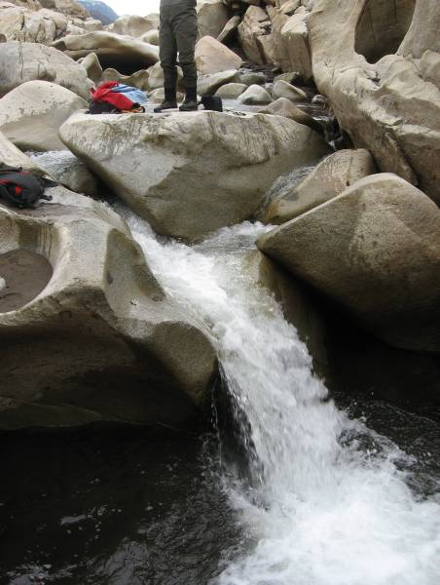

Barriers to Fish Passage – Tributary Confluences and Reservoir Pool Inlets (continued)

Barrier Characteristics

Barrier Identification | River Mile¹ | Location (UTM)² |  | Barrier  Class | Passable |  | Photograph
Barrier Identification | River Mile¹ | Easting | Northing | Barrier  Class | Trout | Minnows³ | Photograph
Rubicon River (continued)
Hell Hole Reservoir Inlet - R35.0 | R35.0 | 728296 | 4329466 | Critical Riffle | YES | NA | 31
Hell Hole Reservoir Inlet - R35.2a | R35.2 | 728726 | 4329320 | Chute | Potential | NA | 32
Hell Hole Reservoir Inlet - R35.2b | R35.2 | 728726 | 4329320 | Chute | Potential | NA | 33
Hell Hole Reservoir Inlet - R35.8a | R35.8 | 729398 | 4328972 | Falls | NO | NA | 34
¹Abbreviation: R = Rubicon
²Universal Transverse Mercator Zone 10 North, North American Datum 1983
³Minnows include hardhead, Sacramento pikeminnow, and Sacramento sucker. Distribution was assumed to be limited to the Middle Fork American River downstream of Middle Fork
Interbay and the Rubicon River downstream of the impassable barrier at river mile 15.3

Barrier Photographs

31 | 32
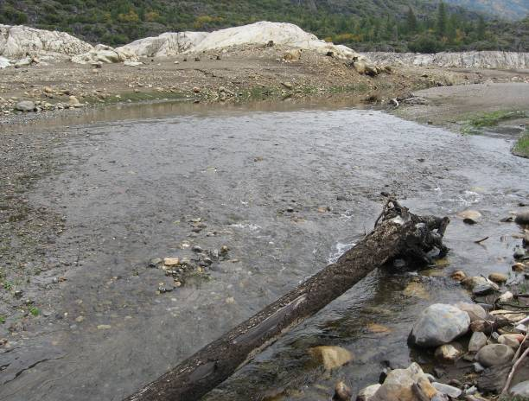 | 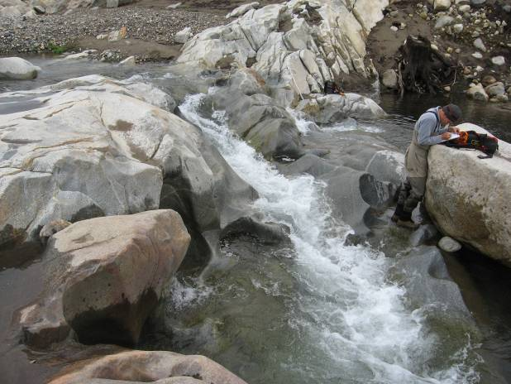
33 | 34
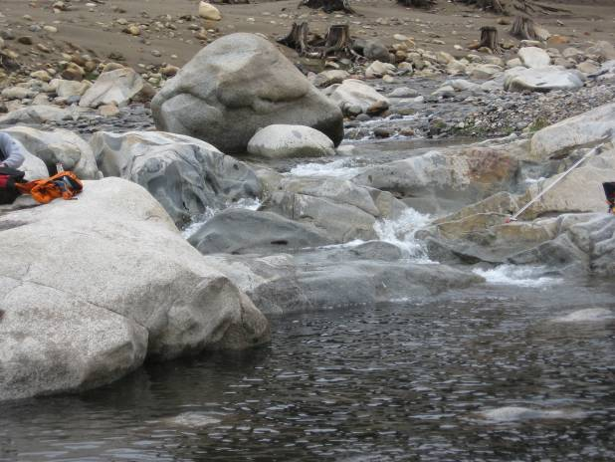 | 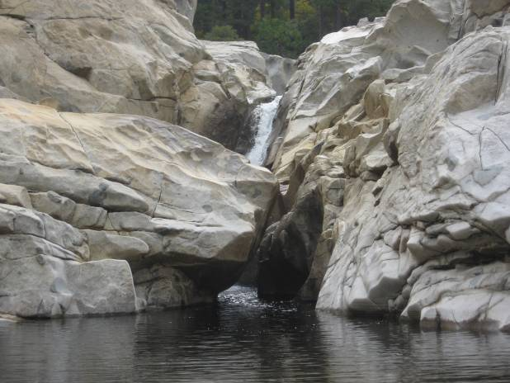

Barriers to Fish Passage – Tributary Confluences and Reservoir Pool Inlets (continued)

Barrier Characteristics

Barrier Identification | River Mile¹ | Location (UTM)² |  | Barrier  Class | Passable |  | Photograph
Barrier Identification | River Mile¹ | Easting | Northing | Barrier  Class | Trout | Minnows³ | Photograph
Rubicon River (continued)
Hell Hole Reservoir Inlet - R35.8b | R35.8 | 729398 | 4328972 | Falls | NO | NA | 35
Five Lakes Creek - R35.7 | R35.7 | 729365 | 4329061 | Critical Riffle | YES | NA | 36
¹Abbreviation: R = Rubicon, 5L = Five Lakes Creek
²Universal Transverse Mercator Zone 10 North, North American Datum 1983
³Minnows include hardhead, Sacramento pikeminnow, and Sacramento sucker. Distribution was assumed to be limited to the Middle Fork American River downstream of Middle Fork
Interbay and the Rubicon River downstream of the impassable barrier at river mile 15.3

Barrier Photographs

35 | 36
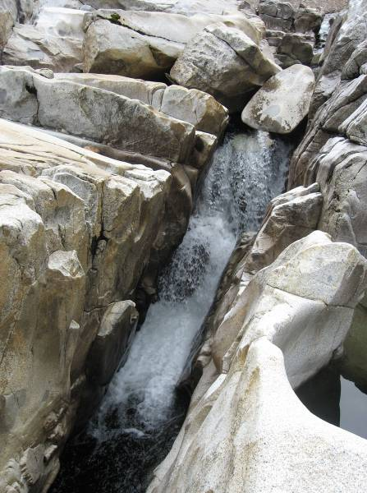 | 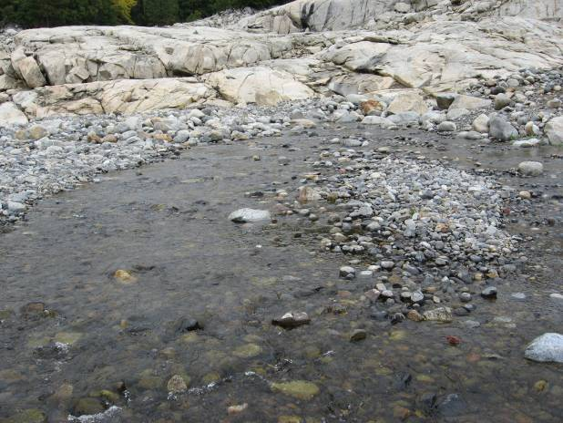

Barriers to Fish Passage – Tributary Confluences and Reservoir Pool Inlets (continued)

Barrier Characteristics

Barrier Identification | River Mile¹ | Location (UTM)² |  | Barrier  Class | Passable |  | Photograph
Barrier Identification | River Mile¹ | Easting | Northing | Barrier  Class | Trout | Minnows³ | Photograph
Rubicon River (continued)
Five Lakes Creek - 5L.0.2a | 5L0.2 | 729698 | 4329091 | Chute | Potential | NA | 37
Five Lakes Creek - 5L.0.2b | 5L0.2 | 729698 | 4329091 | Chute | YES | NA | 37
Five Lakes Creek - 5L.02c | 5L0.2 | 729698 | 4329091 | Chute | YES | NA | 37
Long Canyon Creek
Wallace Canyon | LC5.6 | 707907 | 4317350 | Falls | NO | NA | No Photograph
North and South Forks Long Canyon Creek | LC11.4 | 715085 | 4322064 | No Barrier | YES | NA | No Photograph
North Fork Long Canyon Creek
North Fork Long Canyon Diversion Pool | NFLC3.1 | 717976 | 4325495 | Critical Riffle | YES | NA | 38
¹Abbreviation: 5L = Five Lakes Creek, LC = Long Canyon Creek, NFLC = North Fork Long Canyon Creek
²Universal Transverse Mercator Zone 10 North, North American Datum 1983
³Minnows include hardhead, Sacramento pikeminnow, and Sacramento sucker. Distribution was assumed to be limited to the Middle Fork American River downstream of Middle Fork Interbay
and the Rubicon River downstream of the impassable barrier at river mile 15.3

Barrier Photographs

37 | 38
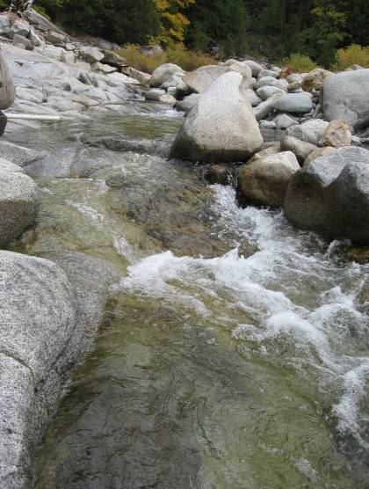 | 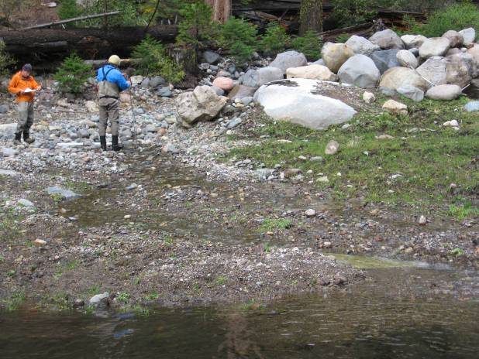

Barriers to Fish Passage – Tributary Confluences and Reservoir Pool Inlets (continued)

Barrier Characteristics

Barrier Identification | River Mile¹ | Location (UTM)² |  | Barrier  Class | Passable |  | Photograph
Barrier Identification | River Mile¹ | Easting | Northing | Barrier  Class | Trout | Minnows³ | Photograph
South Fork Long Canyon Creek
South Fork Long Canyon Diversion Pool Inlet - SFLC3.3 | SFLC3.3 | 718898 | 4325542 | Critical Riffle | Potential | NA | 39
Duncan Creek
Duncan Diversion Pool Inflow | D8.7 | 717753 | 4334749 | No Barrier | YES | NA | 40
North Fork American River
Middle Fork American River | NF21.0 | 670141 | 4309220 | No Barrier | YES | NA | 41
¹Abbreviation: SFLC = South Fork Long Canyon Creek, D = Duncan Creek, NF= North Fork American River
²Universal Transverse Mercator Zone 10 North, North American Datum 1983
³Minnows include hardhead, Sacramento pikeminnow, and Sacramento sucker. Distribution was assumed to be limited to the Middle Fork American River downstream of Middle
Fork Interbay and the Rubicon River downstream of the impassable barrier at river mile 15.3

Barrier Photographs

39 | 40
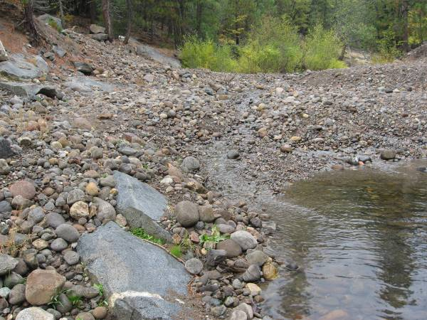 | 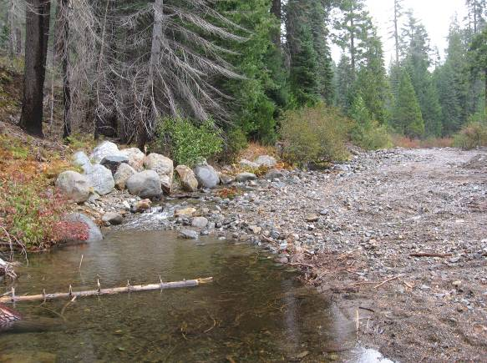
41
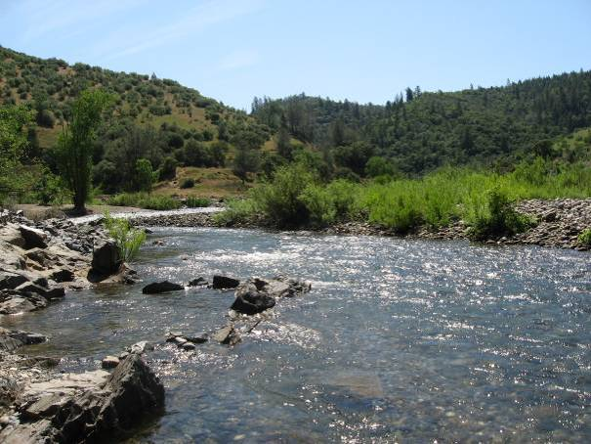

Barriers to Fish Passage – Natural Instream Barriers

Barrier Characteristics

Barrier Identification | River Mile¹ | Location (UTM)² |  | Barrier  Class | Passable |  | Photograph
Barrier Identification | River Mile¹ | Easting | Northing | Barrier  Class | Trout | Minnows³ | Photograph
Middle Fork American River Downstream of Ralston Afterbay
Ruck-a-Chucky Falls - MF10.7a | MF10.7 | 681367 | 4313756 | Falls | NO | NO | 1
Ruck-a-Chucky Falls - MF10.7b | MF10.7 | 681367 | 4313756 | Falls | NO | NO | 1
Ruck-a-Chucky Falls - MF10.7c | MF10.7 | 681367 | 4313756 | Falls | NO | NO | 1
Ruck-a-Chucky Falls - MF10.7d | MF10.7 | 681367 | 4313756 | Falls | NO | NO | 1
Ruck-a-Chucky Falls - MF10.7e | MF10.7 | 681367 | 4313756 | Falls | NO | NO | 1
Ruck-a-Chucky Falls - MF10.7f | MF10.7 | 681367 | 4313756 | Falls | NO | NO | 1
Ruck-a-Chucky Falls - MF10.7g | MF10.7 | 681367 | 4313756 | Falls | NO | NO | 1
¹Abbreviation: MF = Middle Fork American River
²Universal Transverse Mercator Zone 10 North, North American Datum 1983
³Minnows include hardhead, Sacramento pikeminnow, and Sacramento sucker. Distribution was assumed to be limited to the Middle Fork American River downstream of
Middle Fork Interbay and the Rubicon River downstream of the impassable barrier at river mile 15.3

Barrier Photographs

1 | 1
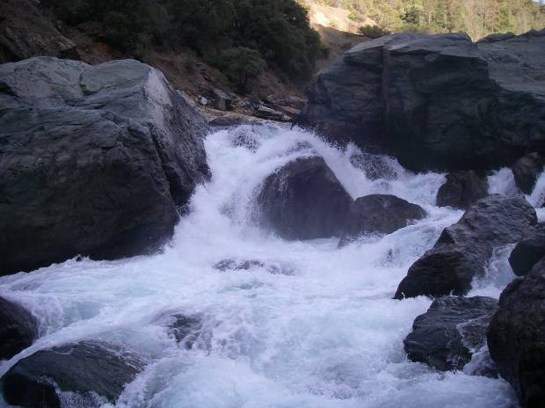 | 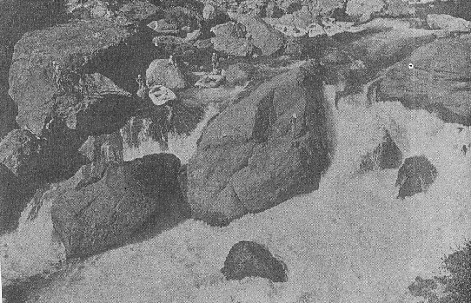
1
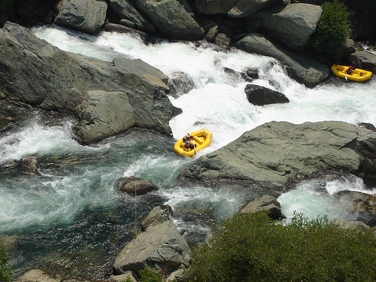

Barriers to Fish Passage – Natural Instream Barriers (continued)

Barrier Characteristics

Barrier Identification | River Mile¹ | Location (UTM)² |  | Barrier  Class | Passable |  | Photograph
Barrier Identification | River Mile¹ | Easting | Northing | Barrier  Class | Trout | Minnows³ | Photograph
Middle Fork American River Downstream of Ralston Afterbay (continued)
Tunnel Chute - MF22.9b | MF22.9 | 693788 | 4319854 | Falls | NO | NO | 2
Tunnel Chute - MF22.9e | MF22.9 | 693788 | 4319854 | Falls | NO | NO | 3
Middle Fork American River from Ralston Afterbay to Middle Fork Interbay
Plunge pool above Ralston Afterbay - MF26.4 | MF26.4 | 696791 | 4320336 | Falls | NO | NO | 4
¹Abbreviation: MF = Middle Fork American River
²Universal Transverse Mercator Zone 10 North, North American Datum 1983
³Minnows include hardhead, Sacramento pikeminnow, and Sacramento sucker. Distribution was assumed to be limited to the Middle Fork American River downstream of
Middle Fork Interbay and the Rubicon River downstream of the impassable barrier at river mile 15.3

Barrier Photographs

2 | 3
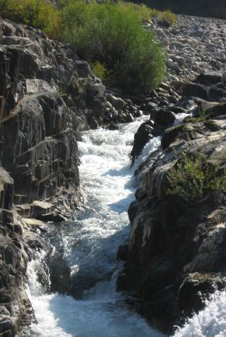 | 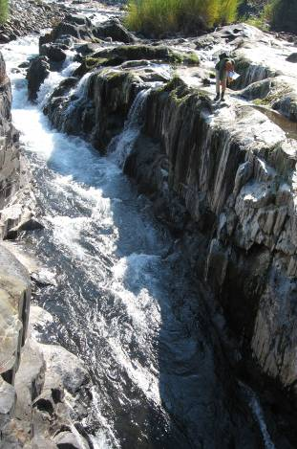
4
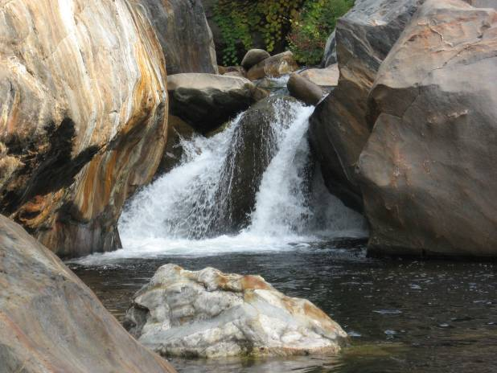

Barriers to Fish Passage – Natural Instream Barriers (continued)

Barrier Characteristics

Barrier Identification | River Mile¹ | Location (UTM)² |  | Barrier  Class | Passable |  | Photograph
Barrier Identification | River Mile¹ | Easting | Northing | Barrier  Class | Trout | Minnows³ | Photograph
Middle Fork American River Upstream of Middle Fork Interbay (continued)
Plunge Pool above Middle Fork Interbay - MF36.3 | MF36.3 | 708416 | 4322621 | Falls | NO | NA | 5
Instream Barrier - MF44.6 | MF44.6 | 716448 | 4329510 | Falls | NO | NA | No Photograph
Instream Barrier - MF44.7 | MF44.7 | 716562 | 4329683 | Falls | NO | NA | No Photograph
Instream Barrier - MF44.8 | MF44.8 | 716569 | 4329873 | Falls | NO | NA | No Photograph
Instream Barrier - MF44.9a | MF44.9 | 716634 | 4329959 | Falls | NO | NA | No Photograph
Instream Barrier - MF44.9b | MF44.9 | 716646 | 4329972 | Falls | NO | NA | No Photograph
Instream Barrier - MF45.2a | MF45.2 | 716809 | 4330351 | Falls | NO | NA | 6
Instream Barrier - MF45.2b | MF45.2 | 716797 | 4330433 | Falls | NO | NA | 7
Instream Barrier - MF45.3 | MF45.3 | 716799 | 4330451 | Falls | NO | NA | 8
Instream Barrier - MF45.4 | MF45.4 | 716961 | 4330701 | Falls | NO | NA | No Photograph
¹Abbreviation: MF = Middle Fork American River
²Universal Transverse Mercator Zone 10 North, North American Datum 1983
³Minnows include hardhead, Sacramento pikeminnow, and Sacramento sucker. Distribution was assumed to be limited to the Middle Fork American River downstream of Middle Fork
Interbay and the Rubicon River downstream of the impassable barrier at river mile 15.3

Barrier Photographs

5 | 6
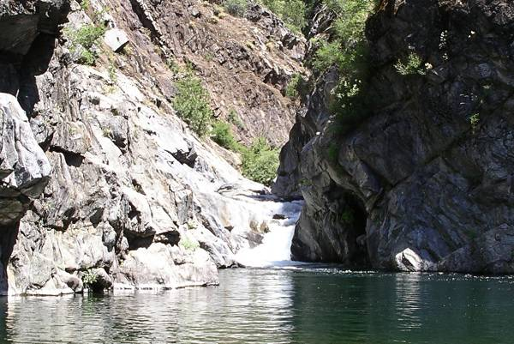 | 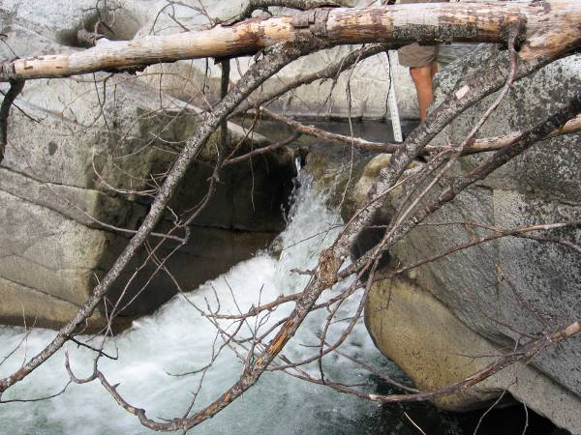
7 | 8
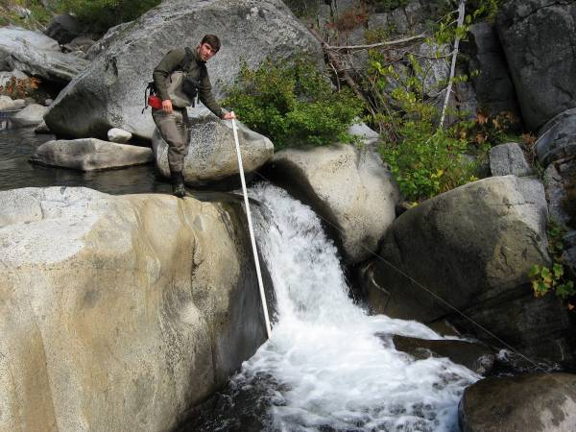 | 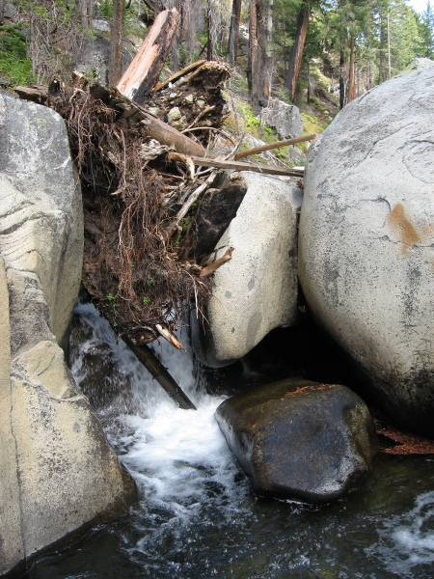

Barriers to Fish Passage – Natural Instream Barriers (continued)

Barrier Characteristics

Barrier Identification | River Mile¹ |  | Location (UTM)² |  |  |  | Barrier  Class |  |  | Passable |  |  |  | Photograph
Barrier Identification |  |  | Easting |  | Northing |  |  |  |  | Trout | Minnows³ |  |  | Photograph
Middle Fork American River Upstream of Middle Fork Interbay (continued)
Instream Barrier – MF57.9 |  | MF57.9 |  | 728358 |  | 4341168 |  | Falls | NO |  |  | NA | 9
Rubicon River
Cascade below Long Canyon Confluence - R3.4a | R3.4 |  | 700006 |  | 4317937 |  | Falls |  |  | NO | NO |  |  | 10
Cascade below Long Canyon Confluence - R3.4b | R3.4 |  | 700006 |  | 4317937 |  | Falls |  |  | Potential | NO |  |  | 10
Instream Barrier - R6.0⁴ | R6.0 |  | 701324 |  | 4315234 |  | Falls |  |  | NO | NO |  |  | 11
Instream Barrier - R8.2⁴ | R8.2 |  | 703773 |  | 4313558 |  | Falls |  |  | NO | NO |  |  | 12
¹Abbreviation: R = Rubicon River
²Universal Transverse Mercator Zone 10 North, North American Datum 1983
³Minnows include hardhead, Sacramento pikeminnow, and Sacramento sucker. Distribution was assumed to be limited to the Middle Fork American River downstream of Middle Fork
Interbay and the Rubicon River downstream of the impassable barrier at river mile 15.3
⁴Surveyed from the ground and from helicopter fly-overs

Barrier Photographs

9 | 10
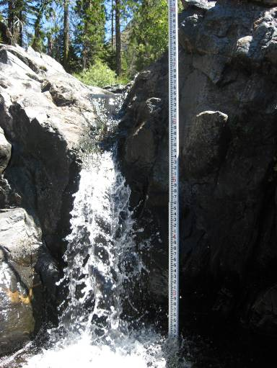 | 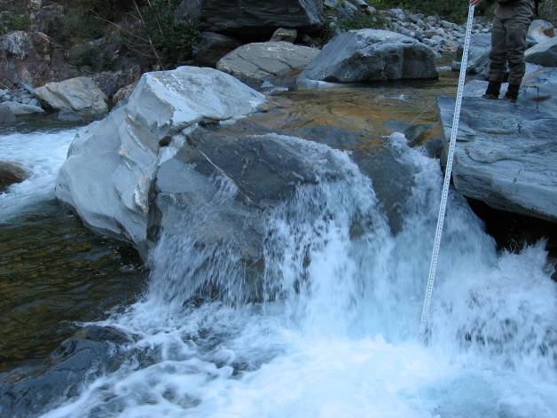
11 |  | 12
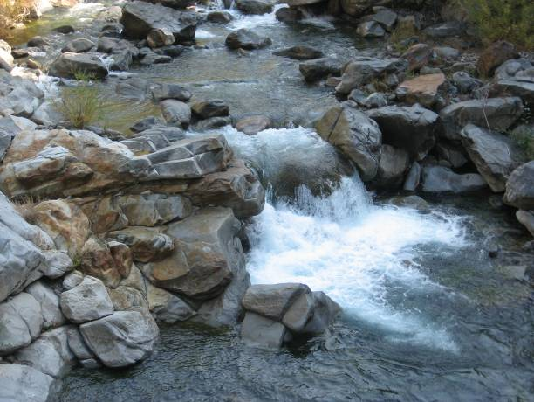 | 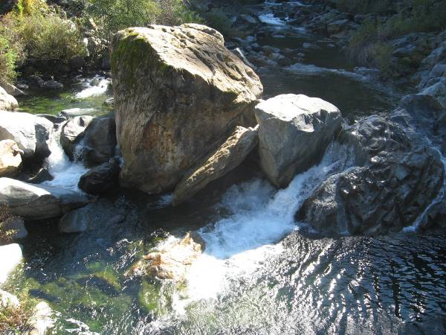

Barriers to Fish Passage – Natural Instream Barriers (continued)

Barrier Characteristics

Barrier Identification | River Mile¹ |  | Location (UTM)² |  |  |  | Barrier  Class |  | Passable |  |  |  | Photograph
Barrier Identification |  |  | Easting |  | Northing |  |  |  | Trout |  | Minnows³
Rubicon River (continued)
Instream Barrier - R15.0a | R15.0 |  | 711660 |  | 4310265 |  | Chute |  | Potential |  | NA |  | 13
Instream Barrier - R15.0b | R15.0 |  | 711712 |  | 4310242 |  | Falls |  | NO |  | NA |  | 14
Instream Barrier - R35.8c |  | R35.8 R35.8 |  | 729415 |  | 4328907 |  | Falls |  | NO |  | NA |  | 15
Instream Barrier - R35.8d |  | R35.8 |  | 729415 |  | 4328907 |  | Chute |  | NO |  | NA |  | 15
Instream Barrier - R35.8e |  | R35.8 |  | 729415 |  | 4328907 |  | Falls |  | NO |  | NA |  | 15
¹Abbreviation: R = Rubicon River
²Universal Transverse Mercator Zone 10 North, North American Datum 1983
³Minnows include hardhead, Sacramento pikeminnow, and Sacramento sucker. Distribution was assumed to be limited to the Middle Fork American River downstream of Middle Fork Interbay and
the Rubicon River downstream of the impassable barrier at river mile 15.3

Barrier Photographs

13 | 14
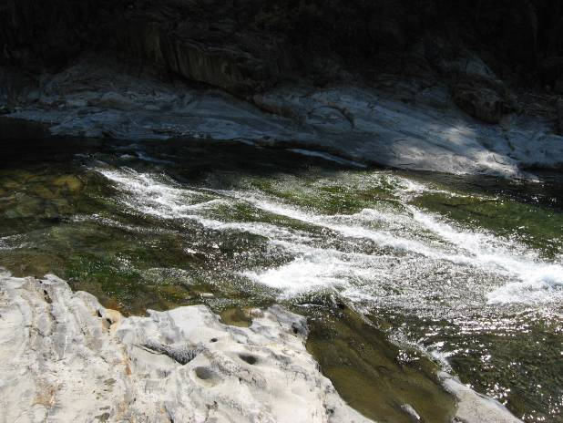 | 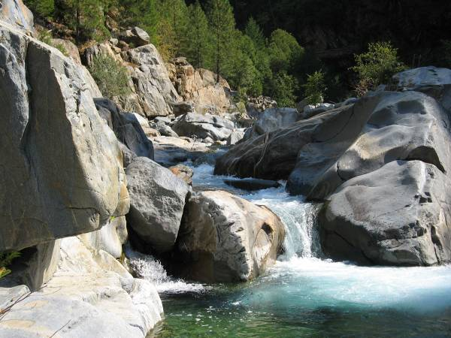
15
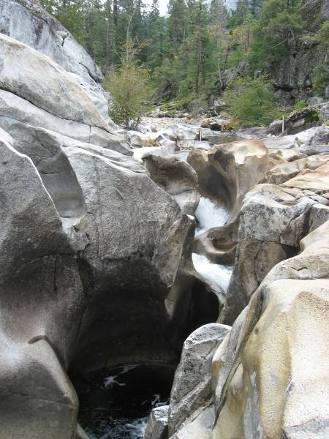

Barriers to Fish Passage – Natural Instream Barriers (continued)

Barrier Characteristics

Barrier Identification | River Mile¹ | Location (UTM)² |  | Barrier  Class | Passable |  | Photograph
Barrier Identification | River Mile¹ | Easting | Northing | Barrier  Class | Trout | Minnows³ | Photograph
Long Canyon Creek
Instream Barrier - LC0.2b | LC0.2 | 700425 | 4318486 | Falls | NO | NO | No Photograph
Instream Barrier - LC0.2c | LC0.2 | 700425 | 4318486 | Falls | NO | NO | 16
Instream Barrier - LC6.0 | LC6.0 | 708448 | 4317678 | Falls | NO | NA | No Photograph
Instream Barrier - LC6.2 | LC6.2 | 708709 | 4317766 | Falls | NO | NA | No Photograph
Instream Barrier - LC6.4 | LC6.4 | 709082 | 4317838 | Falls | NO | NA | No Photograph
Instream Barrier - LC6.5 | LC6.5 | 709116 | 4317844 | Falls | NO | NA | No Photograph
Instream Barrier - LC6.7 | LC6.7 | 709480 | 4317919 | Falls | NO | NA | 17
¹Abbreviation: LC = Long Canyon Creek
²Universal Transverse Mercator Zone 10 North, North American Datum 1983
³Minnows include hardhead, Sacramento pikeminnow, and Sacramento sucker. Distribution was assumed to be limited to the Middle Fork American River downstream of Middle Fork
Interbay and the Rubicon River downstream of the impassable barrier at river mile 15.3

Barrier Photographs

16 | 17
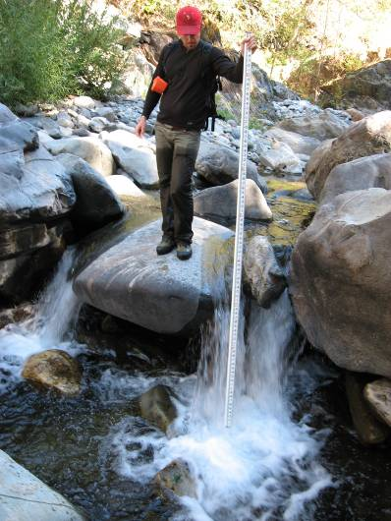 | 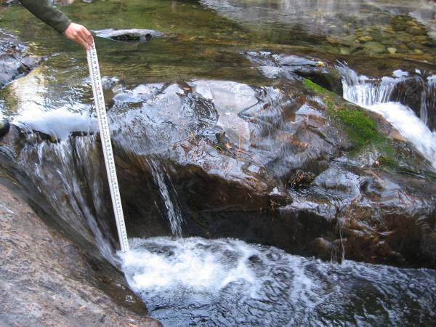

Barriers to Fish Passage – Natural Instream Barriers (continued)

Barrier Characteristics

Barrier Identification | River Mile¹ | Location (UTM)² |  | Barrier Class | Passable |  | Photograph
Barrier Identification | River Mile¹ | Easting | Northing | Barrier Class | Trout | Minnows³ | Photograph
Long Canyon Creek (continued)
Instream Barrier - LC6.8 | LC6.8 | 709578 | 4318008 | Falls | NO | NA | 18
Instream Barrier - LC6.9a | LC6.9 | 709671 | 4318049 | Falls | NO | NA | 19
Instream Barrier - LC6.9b | LC6.9 | 709767 | 4318056 | Falls | NO | NA | 20
Instream Barrier - LC8.2a | LC8.2 | 711293 | 4319193 | Falls | NO | NA | 21
¹Abbreviation: LC = Long Canyon Creek
²Universal Transverse Mercator Zone 10 North, North American Datum 1983
³Minnows include hardhead, Sacramento pikeminnow, and Sacramento sucker. Distribution was assumed to be limited to the Middle Fork American River downstream of Middle
Fork Interbay and the Rubicon River downstream of the impassable barrier at river mile 15.3

Barrier Photographs

18 | 19
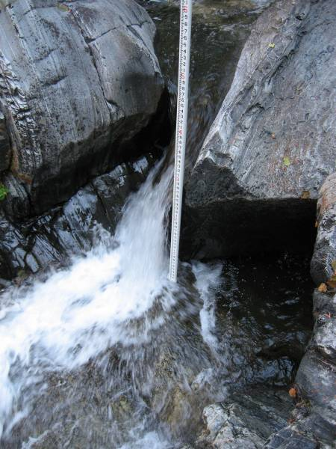 | 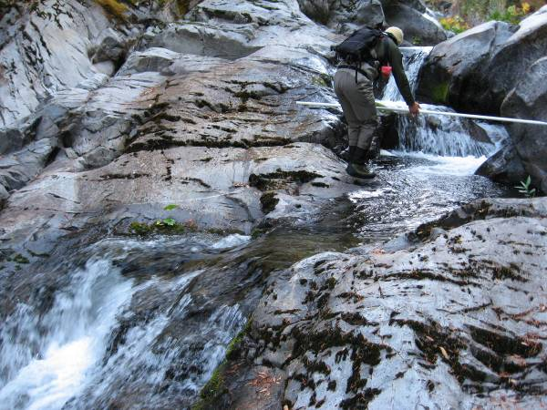
20 | 21
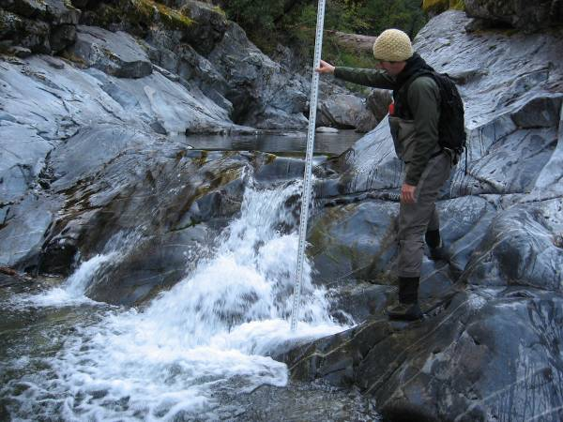 | 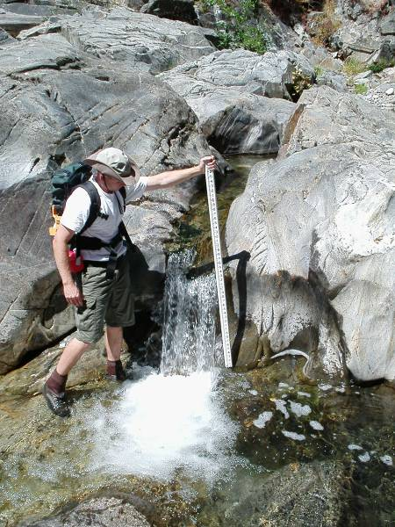

Barriers to Fish Passage – Natural Instream Barriers (continued)

Barrier Characteristics

Barrier Identification | River Mile¹ | Location (UTM)² |  | Barrier Class | Passable |  | Photograph
Barrier Identification | River Mile¹ | Easting | Northing | Barrier Class | Trout | Minnows³ | Photograph
Long Canyon Creek (continued)
Instream Barrier - LC8.2b | LC8.2 | 711293 | 4319193 | Falls | NO | NA | 22
Instream Barrier - LC9.1a | LC9.1 | 712358 | 4319722 | Falls | NO | NA | No Photograph
Instream Barrier - LC9.1b | LC9.1 | 712363 | 4319724 | Falls | NO | NA | No Photograph
Instream Barrier - LC9.8 | LC9.8 | 713247 | 4320390 | Falls | NO | NA | No Photograph
Instream Barrier - LC11.0 | LC11.0 | 714449 | 4321691 | Falls | NO | NA | 23
Instream Barrier - LC11.2a | LC11.2 | 714826 | 4321850 | Chute | NO | NA | 24
Instream Barrier - LC11.2b | LC11.2 | 714840 | 4321863 | Falls | NO | NA | No Photograph
Instream Barrier - LC11.4 | LC11.4 | 715011 | 4322020 | Falls | NO | NA | No Photograph
¹Abbreviation: LC =Long Canyon Creek
²Universal Transverse Mercator Zone 10 North, North American Datum 1983
³Minnows include hardhead, Sacramento pikeminnow, and Sacramento sucker. Distribution was assumed to be limited to the Middle Fork American River downstream of Middle Fork
Interbay and the Rubicon River downstream of the impassable barrier at river mile 15.3

Barrier Photographs

22 | 23
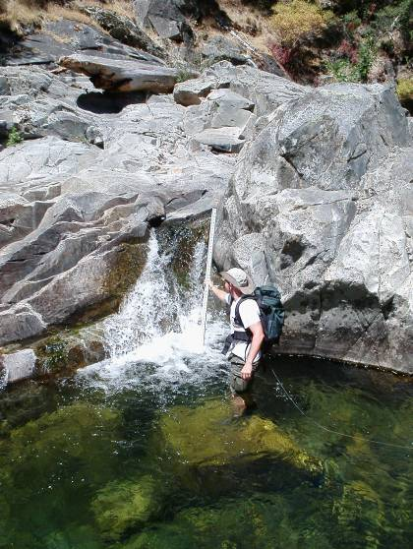 | 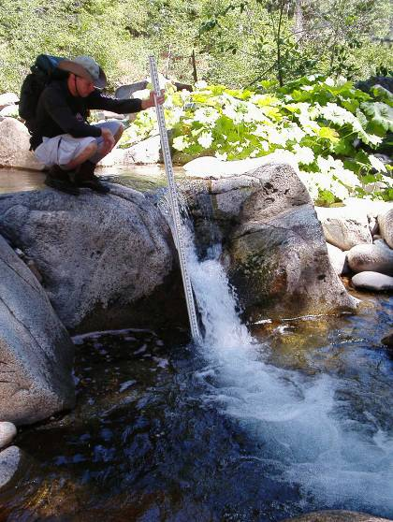
24
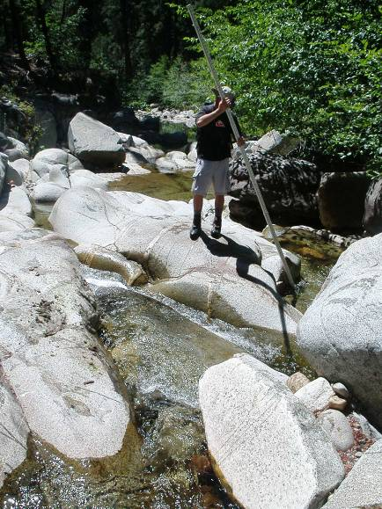

Barriers to Fish Passage – Natural Instream Barriers (continued)

Barrier Characteristics

Barrier Identification | River Mile¹ | Location (UTM)² |  | Barrier Class | Passable |  | Photograph
Barrier Identification | River Mile¹ | Easting | Northing | Barrier Class | Trout | Minnows³ | Photograph
North Fork Long Canyon Creek
Instream Barrier - NFLC0.1 | NFLC0.1 | 715027 | 4322285 | Falls | NO | NA | No Photograph
Instream Barrier - NFLC0.6 | NFLC0.6 | 715156 | 4322961 | Falls | NO | NA | No Photograph
Instream Barrier - NFLC0.7 | NFLC0.7 | 715226 | 4323167 | Falls | NO | NA | No Photograph
Instream Barrier - NFLC0.9 | NFLC0.9 | 715347 | 4323376 | Falls | NO | NA | No Photograph
Instream Barrier - NFLC1.6 | NFLC1.6 | 716053 | 4324201 | Falls | NO | NA | No Photograph
Instream Barrier - NFLC1.7 | NFLC1.7 | 716231 | 4324248 | Falls | Potential | NA | No Photograph
Instream Barrier - NFLC4.0 | NFLC4.0 | 718750 | 4326499 | Falls | NO | NA | No Photograph
¹Abbreviation: NFLC = North Fork Long Canyon Creek
²Universal Transverse Mercator Zone 10 North, North American Datum 1983
³Minnows include hardhead, Sacramento pikeminnow, and Sacramento sucker. Distribution was assumed to be limited to the Middle Fork American River downstream of Middle
Fork Interbay and the Rubicon River downstream of the impassable barrier at river mile 15.3

Barriers to Fish Passage – Natural Instream Barriers (continued)

Barrier Characteristics

Barrier Identification | River Mile¹ | Location (UTM)² |  | Barrier Class | Passable |  | Photograph
Barrier Identification | River Mile¹ | Easting | Northing | Barrier Class | Trout | Minnows³ | Photograph
South Fork Long Canyon Creek
Instream Barrier - SFLC0.7 | SFLC0.7 | 716113 | 4322571 | Falls | NO | NA | No Photograph
Instream Barrier - SFLC0.8 | SFLC0.8 | 716145 | 4322604 | Chute | NO | NA | No Photograph
Instream Barrier - SFLC1.4a | SFLC1.4 | 716897 | 4323261 | Falls | Potential | NA | No Photograph
Instream Barrier - SFLC1.4b | SFLC1.4 | 716897 | 4323261 | Falls | Potential | NA | No Photograph
Plunge Pool below South Fork Long Canyon Diversion Dam - SFLC3.2a | SFLC3.2 | 718715 | 4325377 | Chute | NO | NA | 25
Plunge Pool below South Fork Long Canyon Diversion Dam - SFLC3.2b | SFLC3.2 | 718715 | 4325377 | Falls | NO | NA | 26
Plunge Pool below South Fork Long Canyon Diversion Dam - SFLC3.2c | SFLC3.2 | 718715 | 4325377 | Chute | NO | NA | 26
Plunge Pool below South Fork Long Canyon Diversion Dam - SFLC3.2d | SFLC3.2 | 718715 | 4325377 | Falls | Potential | NA | 27
Dewatered Section above South Fork Long Canyon Diversion Dam | SFLC3.6-4.0 | 722955 | 4324677 | Dry | NO | NA | 28
¹Abbreviation: SFLC = South Fork Long Canyon Creek
²Universal Transverse Mercator Zone 10 North, North American Datum 1983
³Minnows include hardhead, Sacramento pikeminnow, and Sacramento sucker. Distribution was assumed to be limited to the Middle Fork American River downstream of Middle Fork
Interbay and the Rubicon River downstream of the impassable barrier at river mile 15.3

Barrier Photographs

25 | 26
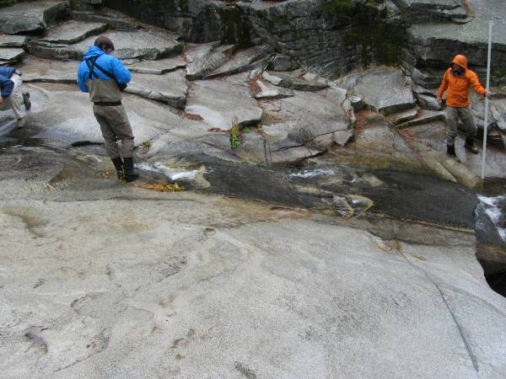 | 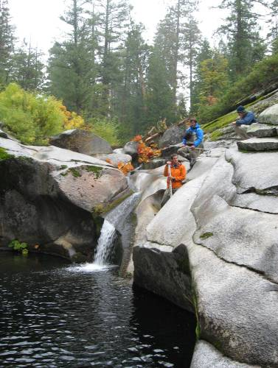
27 | 28
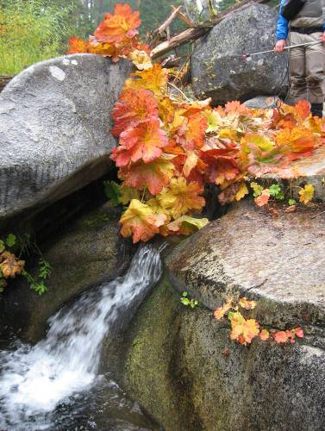 | 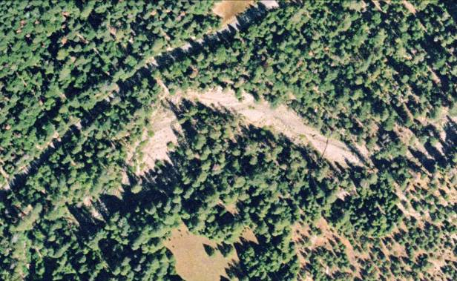

Barriers to Fish Passage – Natural Instream Barriers (continued)

Barrier Characteristics

Barrier Identification | River Mile¹ | Location (UTM)² |  | Barrier Class | Passable |  | Photograph
Barrier Identification | River Mile¹ | Easting | Northing | Barrier Class | Trout | Minnows³ | Photograph
Duncan Creek
Instream Barrier - D4.4 | D4.4 | 713828 | 4329912 | Falls | NO | NA | No Photograph
Instream Barrier - D6.3 | D6.3 | 715550 | 4332222 | Falls | NO | NA | No Photograph
Instream Barrier - D6.4 | D6.4 | 715644 | 4332365 | Falls | Potential | NA | No Photograph
Instream Barrier - D6.8 | D6.8 | 716060 | 4332768 | Falls | Potential | NA | 29
Instream Barrier - D7.2 | D7.2 | 716466 | 4333135 | Falls | Potential | NA | No Photograph
Instream Barrier - D8.2 | D8.2 | 717224 | 4334357 | Falls | Potential | NA | 30
Instream Barrier - D8.4a | D8.4 | 717451 | 4334510 | Falls | Potential | NA | 31
Instream Barrier - D8.4b | D8.4 | 717479 | 4334525 | Falls | Potential | NA | 32
Instream Barrier - D9.0a | D9.0 | 718156 | 4334939 | Falls | NO | NA | No Photograph
¹Abbreviation: D= Duncan Creek
²Universal Transverse Mercator Zone 10 North, North American Datum 1983
³Minnows include hardhead, Sacramento pikeminnow, and Sacramento sucker. Distribution was assumed to be limited to the Middle Fork American River downstream of Middle Fork
Interbay and the Rubicon River downstream of the impassable barrier at river mile 15.3

Barrier Photographs

29 | 30
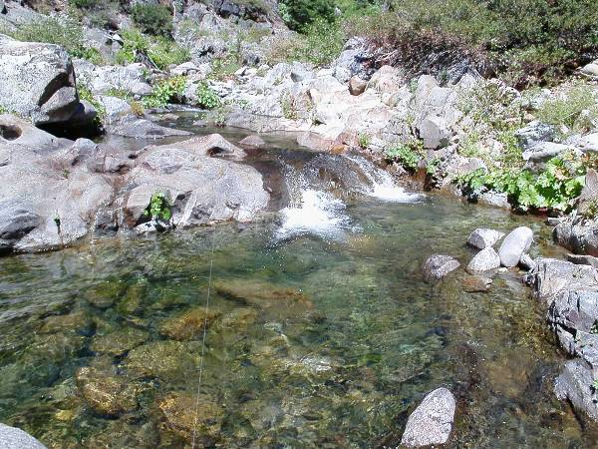 | 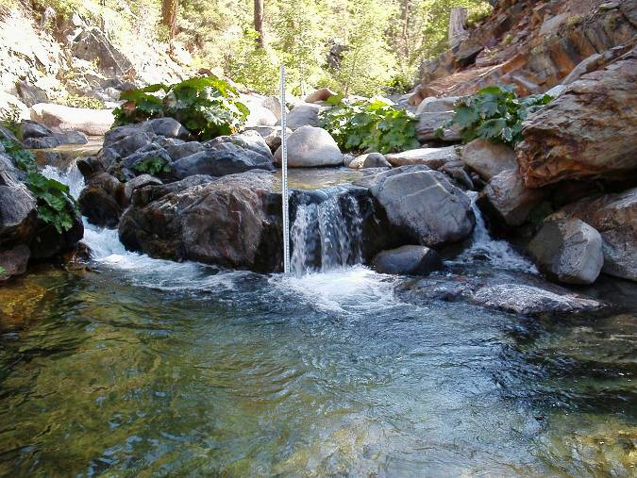
31 | 32
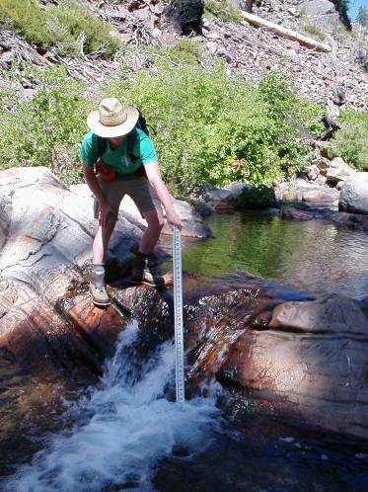 | 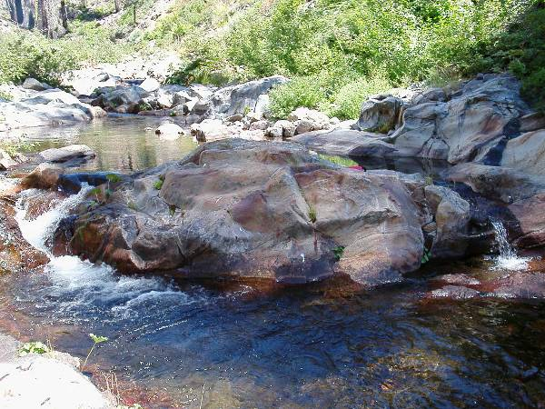

Barriers to Fish Passage – Natural Instream Barriers (continued)

Barrier Characteristics

Barrier Identification | River Mile¹ |  |  | Location (UTM)² |  |  | Barrier Class | Passable |  |  |  |  | Photograph
Barrier Identification |  |  |  | Easting | Northing |  | Barrier Class | Trout |  | Minnows³ |  |  | Photograph
Duncan Creek (continued)
Bedrock section above Duncan Diversion Dam - D9.0b |  | D9.0 | 718171 |  | 4335094 | Chute |  |  | Potential |  | NA | 33
Bedrock section above Duncan Diversion Dam - D9.1a |  | D9.1 | 718150 |  | 4335148 | Chute |  |  | Potential |  | NA | 34
Bedrock section above Duncan Diversion Dam - D9.1b |  | D9.1 | 718150 |  | 4335148 | Falls |  |  | NO |  | NA | 34
¹Abbreviation: D= Duncan Creek
²Universal Transverse Mercator Zone 10 North, North American Datum 1983
³Minnows include hardhead, Sacramento pikeminnow, and Sacramento sucker. Distribution was assumed to be limited to the Middle Fork American River downstream of Middle
Fork Interbay and the Rubicon River downstream of the impassable barrier at river mile 15.3

Barrier Photographs

33 | 34
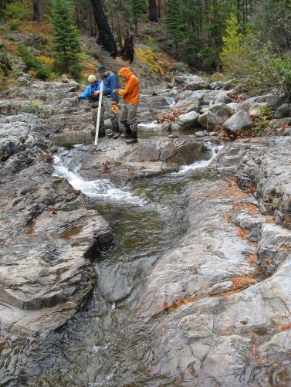 | 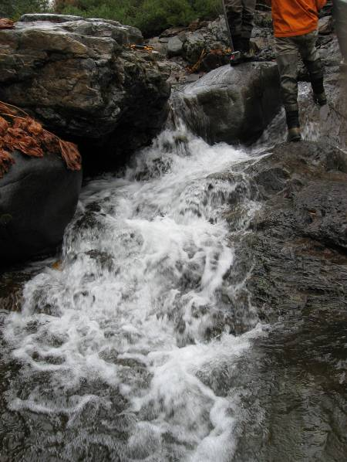
34
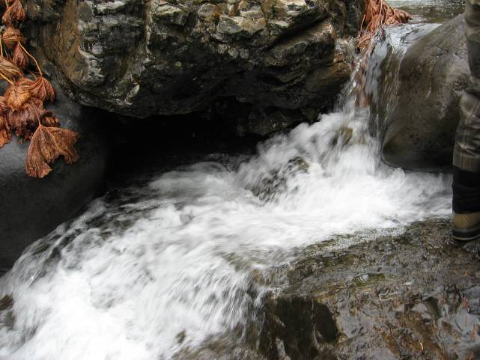

Barriers to Fish Passage – Barriers Assessed from Low Altitude Helicopter Survey

Barrier Characteristics

Barrier Identification | River Mile¹ | Location (UTM)² |  | Barrier Class | Passable |  | Photograph
Barrier Identification | River Mile¹ | Easting | Northing | Barrier Class | Trout | Minnows³ | Photograph
Middle Fork American River from Ralston Afterbay to Middle Fork Interbay
Instream Barrier Qual - MF26.6a | MF26.6 | 696959 | 4320557 | Falls | NO | NO | 1
Instream Barrier Qual - MF26.6b | MF26.6 | 696959 | 4320557 | Falls | NO | NO | 2
Instream Barrier Qual - MF26.6c | MF26.6 | 696959 | 4320557 | Falls | NO | NO | 3
Instream Barrier Qual - MF26.6d | MF26.6 | 696959 | 4320557 | Falls | Potential | NO | 4
¹Abbreviation: MF = Middle Fork American River
²Universal Transverse Mercator Zone 10 North, North American Datum 1983
³Minnows include hardhead, Sacramento pikeminnow, and Sacramento sucker. Distribution was assumed to be limited to the Middle Fork American River downstream of
Middle Fork Interbay and the Rubicon River downstream of the impassable barrier at river mile 15.3

Barrier Photographs
1 | 2
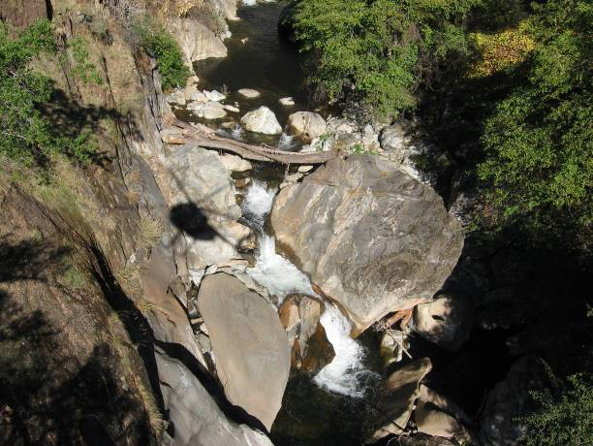 | 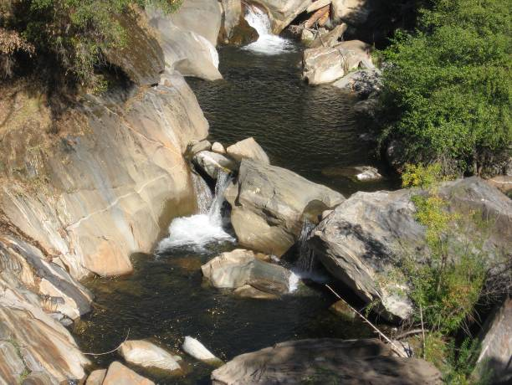
3 | 4
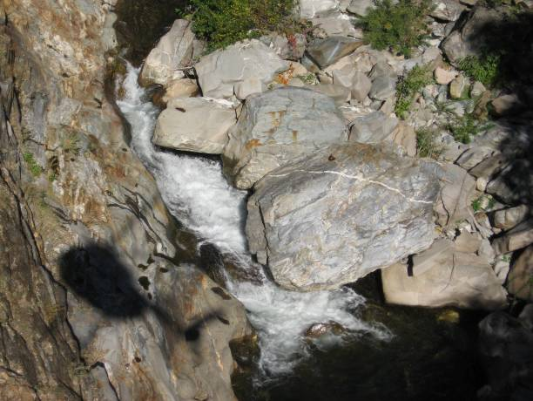 | 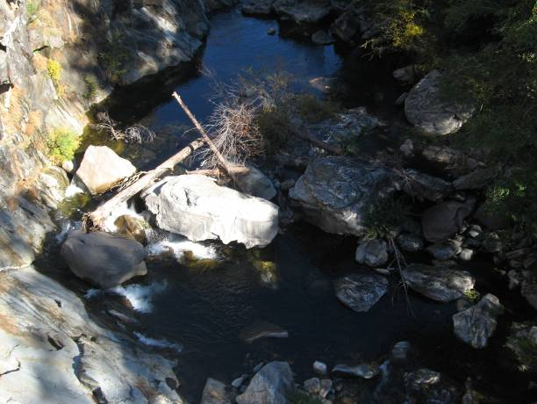

Barriers to Fish Passage – Barriers Assessed from Low Altitude Helicopter Survey (continued)

Barrier Characteristics

Barrier Identification | River Mile¹ | Location (UTM)² |  | Barrier Class | Passable |  | Photograph
Barrier Identification | River Mile¹ | Easting | Northing | Barrier Class | Trout | Minnows³ | Photograph
Middle Fork American River from Ralston Afterbay to Middle Fork Interbay (continued)
Instream Barrier Qual - MF26.6e | MF26.6 | 696959 | 4320557 | Falls | Potential | NO | 5
Rubicon River
Instream Barrier Qual - R3.9 | R3.9 | 700514 | 4317912 | Falls | Potential | Potential | 6
Instream Barrier Qual - R4.2 | R4.2 | 700496 | 4317514 | Falls | Potential | Potential | 7
Instream Barrier Qual - R4.5 | R4.5 | 700727 | 4317090 | Falls | Potential | Potential | 8
¹Abbreviation: MF= Middle Fork American River, R = Rubicon River
²Universal Transverse Mercator Zone 10 North, North American Datum 1983
³Minnows include hardhead, Sacramento pikeminnow, and Sacramento sucker. Distribution was assumed to be limited to the Middle Fork American River downstream of
Middle Fork Interbay and the Rubicon River downstream of the impassable barrier at river mile 15.3

Barrier Photographs

5 | 6
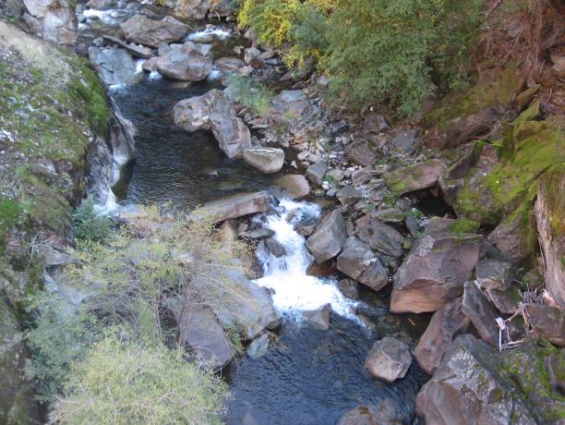 | 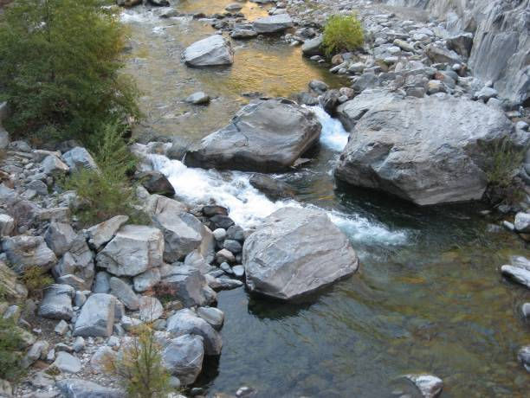
7 | 8
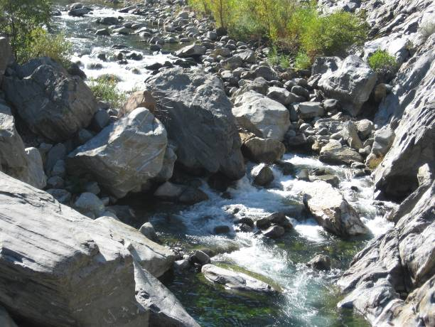 | 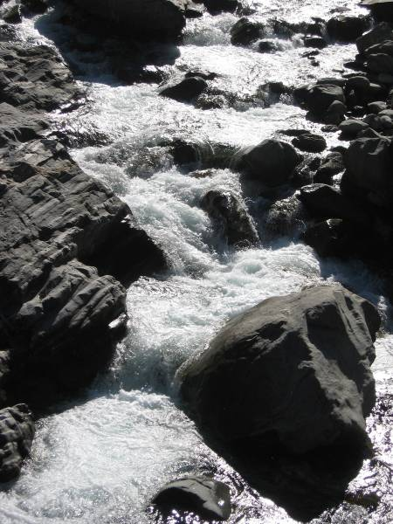

Barriers to Fish Passage – Barriers Assessed from Low Altitude Helicopter Survey (continued)

Barrier Characteristics

Barrier Identification | River Mile¹ | Location (UTM)² |  | Barrier Class | Passable |  | Photograph
Barrier Identification | River Mile¹ | Easting | Northing | Barrier Class | Trout | Minnows³ | Photograph
Rubicon River (continued)
Instream Barrier Qual - R4.6 | R4.6 | 700905 | 4316927 | Falls | Potential | Potential | 9
Instream Barrier Qual - R4.7 | R4.7 | 700912 | 4316800 | Falls | Potential | Potential | 10
Instream Barrier Qual - R5.1 | R5.1 | 700728 | 4316285 | Falls | Potential | Potential | 11
Instream Barrier Qual - R6.0⁴ | R6.0 | 701324 | 4315253 | Falls | NO | NO | 12
¹Abbreviation: R = Rubicon River
²Universal Transverse Mercator Zone 10 North, North American Datum 1983
³Minnows include hardhead, Sacramento pikeminnow, and Sacramento sucker. Distribution was assumed to be limited to the Middle Fork American River downstream of
Middle Fork Interbay and the Rubicon River downstream of the impassable barrier at river mile 15.3
⁴Surveyed from the ground and from helicopter fly-overs

Barrier Photographs

9 | 10
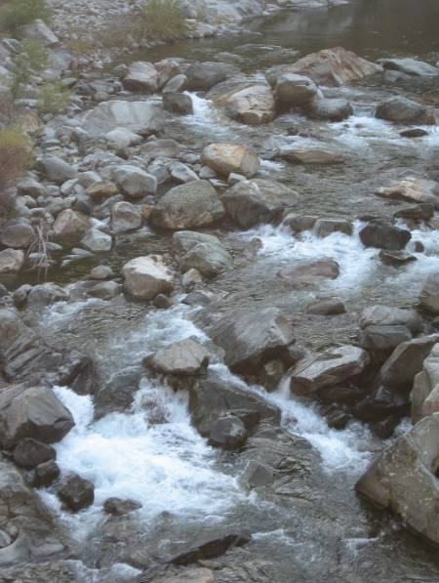 | 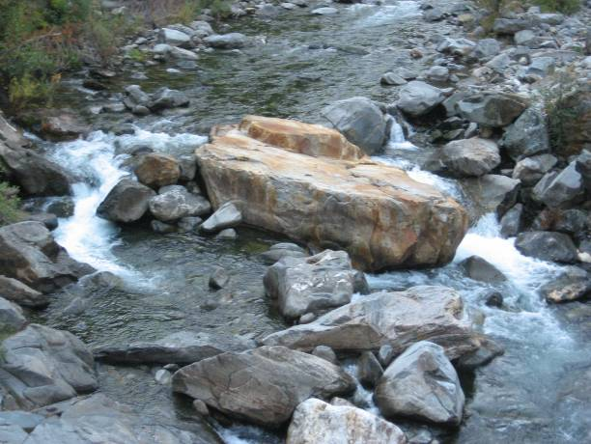
11 | 12
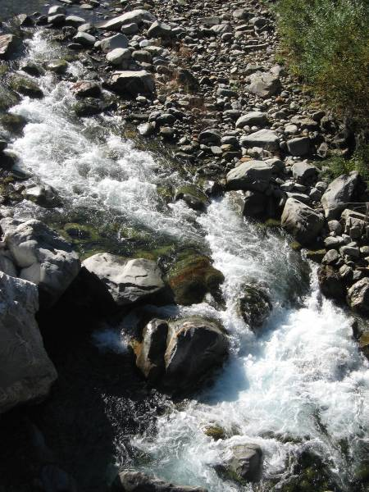

Barriers to Fish Passage – Barriers Assessed from Low Altitude Helicopter Survey (continued)

Barrier Characteristics

Barrier Identification | River Mile¹ | Location (UTM)² |  | Barrier Class | Passable |  | Photograph
Barrier Identification | River Mile¹ | Easting | Northing | Barrier Class | Trout | Minnows³ | Photograph
Rubicon River (continued)
Instream Barrier Qual - R6.1 | R6.1 | 701467 | 4315256 | Falls | Potential | Potential | 13
Instream Barrier Qual - R7.7b | R7.7 | 703219 | 4313731 | Falls | Potential | Potential | 14
Instream Barrier Qual - R7.8 | R7.8 | 703272 | 4313640 | Falls | Potential | Potential | 15
Instream Barrier Qual - R7.9 | R7.9 | 703447 | 4313690 | Chute | Potential | Potential | 16
¹Abbreviation: R = Rubicon River
²Universal Transverse Mercator Zone 10 North, North American Datum 1983
³Minnows include hardhead, Sacramento pikeminnow, and Sacramento sucker. Distribution was assumed to be limited to the Middle Fork American River downstream of
Middle Fork Interbay and the Rubicon River downstream of the impassable barrier at river mile 15.3

Barrier Photographs

13 | 14
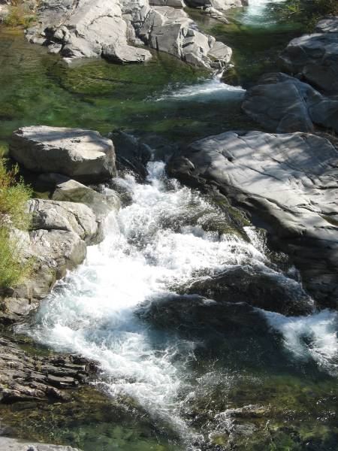 | 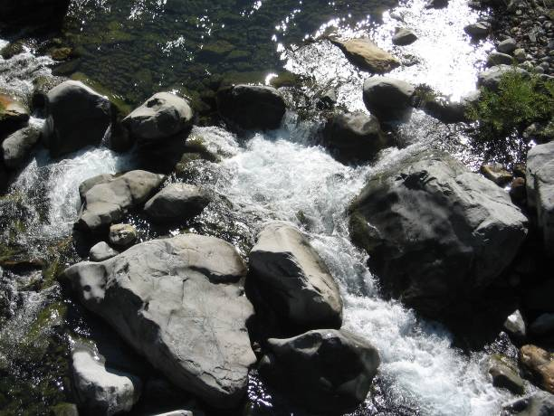
15 | 16
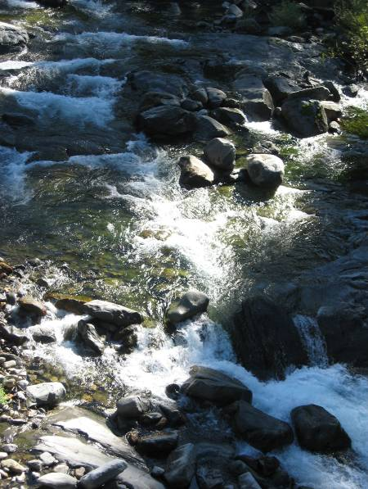 | 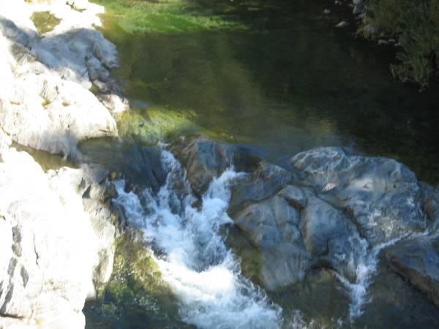

Barriers to Fish Passage – Barriers Assessed from Low Altitude Helicopter Survey (continued)

Barrier Characteristics

Barrier Identification | River Mile¹ | Location (UTM)² |  | Barrier Class | Passable |  | Photograph
Barrier Identification | River Mile¹ | Easting | Northing | Barrier Class | Trout | Minnows³
Rubicon River (continued)
Instream Barrier Qual - R8.0 | R8.0 | 703502 | 4313738 | Falls | Potential | Potential | 17
Instream Barrier Qual - R8.2⁴ | R8.2 | 703773 | 4313558 | Falls | NO | NO | 18
Instream Barrier Qual - R8.7 | R8.7 | 704451 | 4313250 | Falls | Potential | NA | 19
Instream Barrier Qual - R8.8 | R8.8 | 704565 | 4313261 | Falls | Potential | NA | 20
¹Abbreviation: R = Rubicon River
²Universal Transverse Mercator Zone 10 North, North American Datum 1983
³Minnows include hardhead, Sacramento pikeminnow, and Sacramento sucker. Distribution was assumed to be limited to the Middle Fork American River downstream of
Middle Fork Interbay and the Rubicon River downstream of the impassable barrier at river mile 15.3
⁴Surveyed from the ground and from helicopter fly-overs

Barrier Photographs

17 | 18
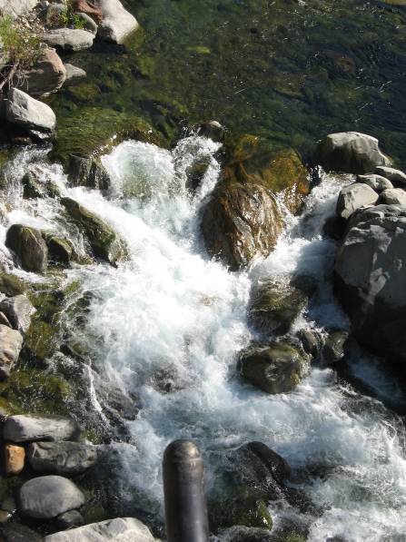
19 | 20
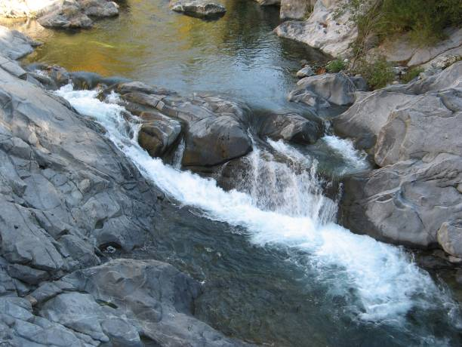 | 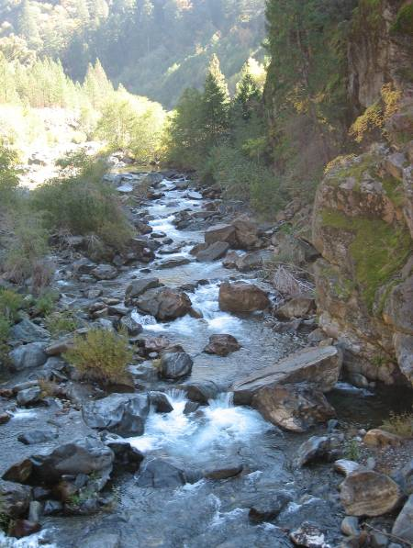

Barriers to Fish Passage – Barriers Assessed from Low Altitude Helicopter Survey (continued)

Barrier Characteristics

Barrier Identification | River Mile¹ | Location (UTM)² |  | Barrier Class | Passable |  | Photograph
Barrier Identification | River Mile¹ | Easting | Northing | Barrier Class | Trout | Minnows³ | Photograph
Rubicon River (continued)
Instream Barrier Qual - R8.9 | R8.9 | 704756 | 4313191 | Falls | Potential | NA | 21
Instream Barrier Qual - R9.7 | R9.7 | 705913 | 4313306 | Falls | Potential | NA | 22
Instream Barrier Qual - R9.8 | R9.8 | 705972 | 4313246 | Falls | Potential | NA | 23
Instream Barrier Qual - R10.2 | R10.2 | 706567 | 4313121 | Falls | Potential | NA | 24
¹Abbreviation: R = Rubicon River
²Universal Transverse Mercator Zone 10 North, North American Datum 1983
³Minnows include hardhead, Sacramento pikeminnow, and Sacramento sucker. Distribution was assumed to be limited to the Middle Fork American River downstream of
Middle Fork Interbay and the Rubicon River downstream of the impassable barrier at river mile 15.3

Barrier Photographs

21 | 22
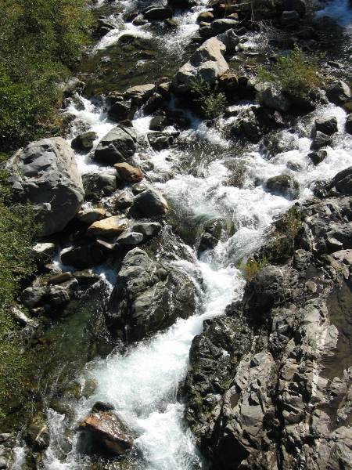 | 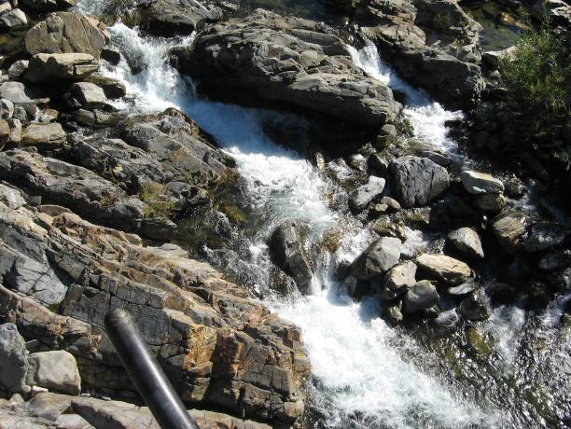
23 | 24
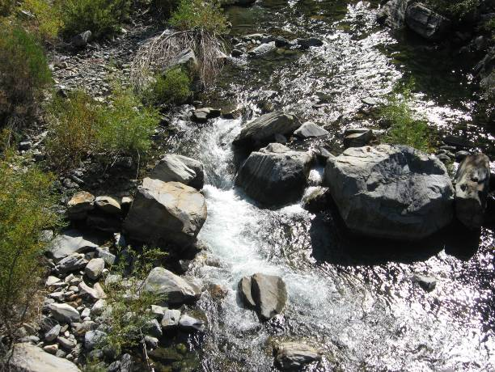 | 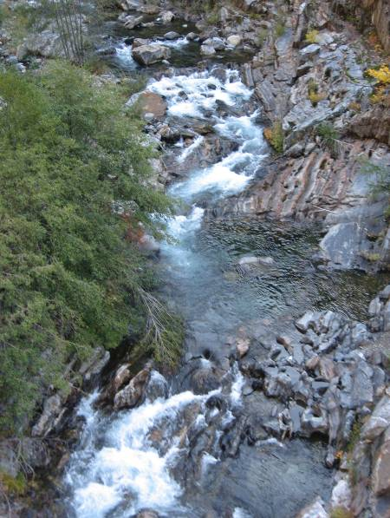

Barriers to Fish Passage – Barriers Assessed from Low Altitude Helicopter Survey (continued)

Barrier Characteristics

Barrier Identification | River Mile¹ | Location (UTM)² |  | Barrier Class | Passable |  | Photograph
Barrier Identification | River Mile¹ | Easting | Northing | Barrier Class | Trout | Minnows³ | Photograph
Rubicon River (continued)
Instream Barrier Qual - R10.7 | R10.7 | 707200 | 4312745 | Falls | Potential | NA | 25
Instream Barrier Qual - R10.8 | R10.8 | 707258 | 4312581 | Falls | Potential | NA | 26
Instream Barrier Qual - R11.2a | R11.2 | 707600 | 4312208 | Falls | Potential | NA l | 27
Instream Barrier Qual - R11.2b | R11.2 | 707653 | 4312216 | Falls | Potential | NA | 28
¹Abbreviation: R = Rubicon River
²Universal Transverse Mercator Zone 10 North, North American Datum 1983
³Minnows include hardhead, Sacramento pikeminnow, and Sacramento sucker. Distribution was assumed to be limited to the Middle Fork American River downstream of
Middle Fork Interbay and the Rubicon River downstream of the impassable barrier at river mile 15.3

Barrier Photographs

25 | 26
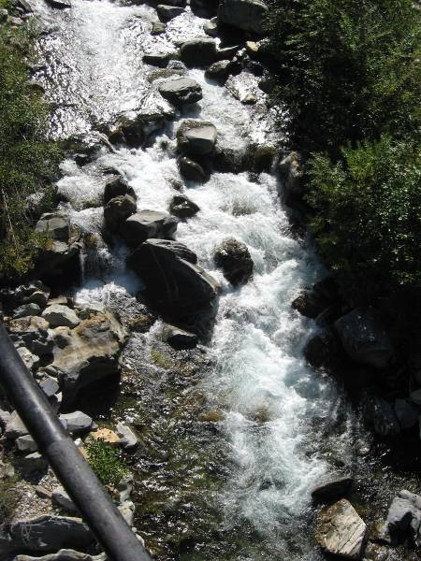 | 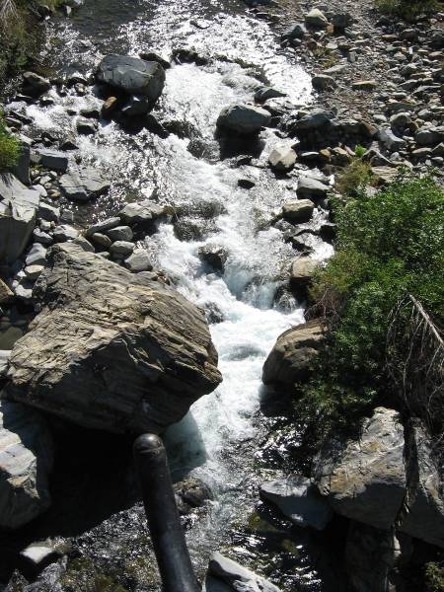
27 | 28
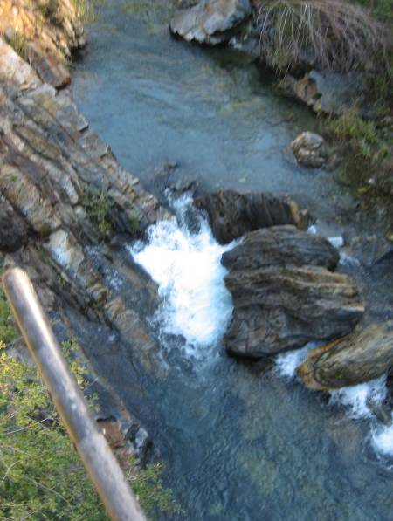 | 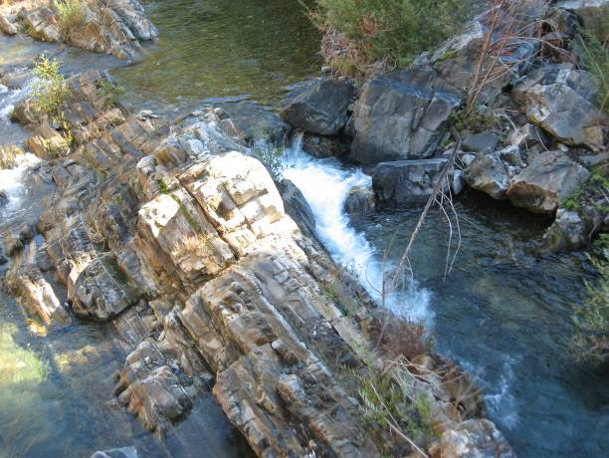

Barriers to Fish Passage – Barriers Assessed from Low Altitude Helicopter Survey (continued)

Barrier Characteristics

Barrier Identification | River Mile¹ | Location (UTM)² |  | Barrier Class | Passable |  | Photograph
Barrier Identification | River Mile¹ | Easting | Northing | Barrier Class | Trout | Minnows³ | Photograph
Rubicon River (continued)
Instream Barrier Qual - R11.8 | R11.8 | 708457 | 4312479 | Falls | Potential | NA | 29
Instream Barrier Qual - R12.2 | R12.2 | 708694 | 4311945 | Falls | Potential | NA | 30
Instream Barrier Qual - R12.6 | R12.6 | 709204 | 4311738 | Falls | Potential | NA | 31
Instream Barrier Qual - R13.0 | R13.0 | 709240 | 4311086 | Falls | Potential | NA | 32
¹Abbreviation: R = Rubicon River
²Universal Transverse Mercator Zone 10 North, North American Datum 1983
³Minnows include hardhead, Sacramento pikeminnow, and Sacramento sucker. Distribution was assumed to be limited to the Middle Fork American River downstream of
Middle Fork Interbay and the Rubicon River downstream of the impassable barrier at river mile 15.3

Barrier Photographs

29 | 30
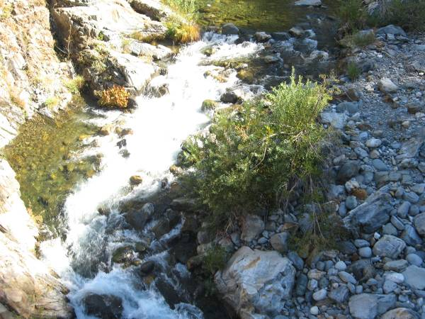 | 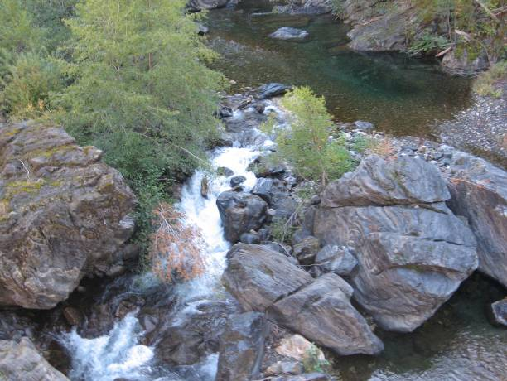
31 | 32
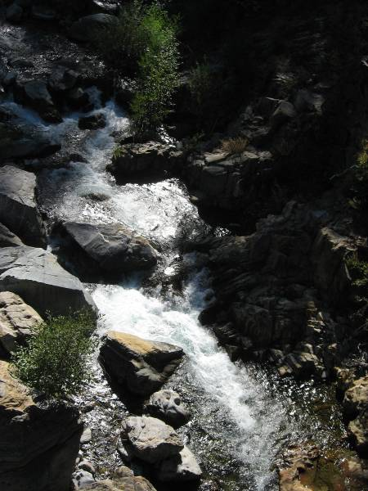 | 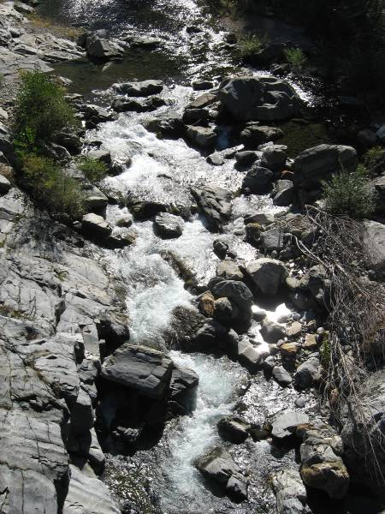

Barriers to Fish Passage – Barriers Assessed from Low Altitude Helicopter Survey (continued)

Barrier Characteristics

Barrier Identification | River Mile¹ | Location (UTM)² |  | Barrier Class | Passable |  | Photograph
Barrier Identification | River Mile¹ | Easting | Northing | Barrier Class | Trout | Minnows³ | Photograph
Rubicon River (continued)
Instream Barrier Qual - R13.2 | R13.2 | 709340 | 4310931 | Falls | Potential | NA | 33
Instream Barrier Qual - R14.6 | R14.6 | 711068 | 4310035 | Falls | Potential | NA | 34
Instream Barrier Qual - R14.9 | R14.9 | 711557 | 4310202 | Falls | Potential | NA | 35
Instream Barrier Qual - R15.3 | R15.3 | 711956 | 4310434 | Chute | NO | NA | 36
¹Abbreviation: R = Rubicon River
²Universal Transverse Mercator Zone 10 North, North American Datum 1983
³Minnows include hardhead, Sacramento pikeminnow, and Sacramento sucker. Distribution was assumed to be limited to the Middle Fork American River downstream of Middle
Fork Interbay and the Rubicon River downstream of the impassable barrier at river mile 15.3

Barrier Photographs

33 | 34
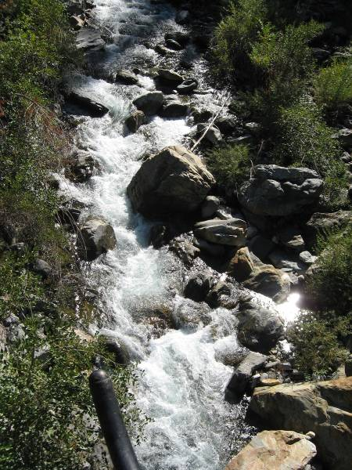 | 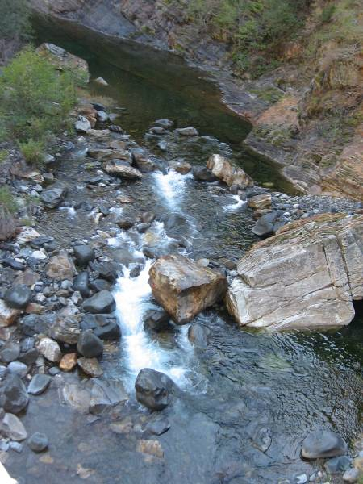
35 | 36
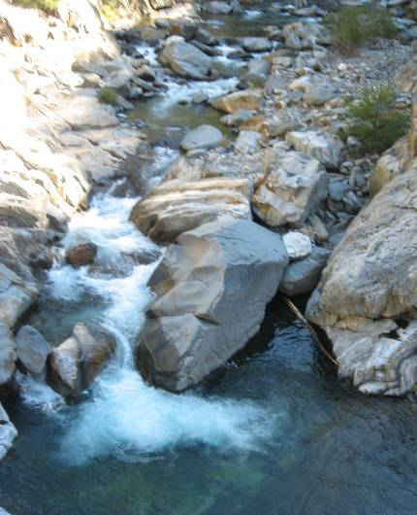 | 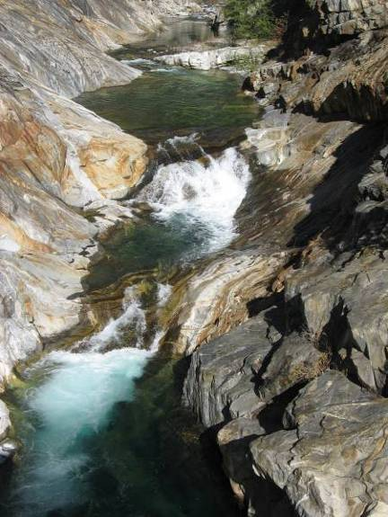

Barriers to Fish Passage – Barriers Assessed from Low Altitude Helicopter Survey (continued)

Barrier Characteristics

Barrier Identification | River Mile¹ | Location (UTM)² |  | Barrier Class | Passable |  | Photograph
Barrier Identification | River Mile¹ | Easting | Northing | Barrier Class | Trout | Minnows³ | Photograph
Rubicon River (continued)
Sedimentation from Dam Failure Event - R28.9 | R28.9 | 722955 | 4324677 | Dry | NO | NA | 37
¹Abbreviation: R = Rubicon River
²Universal Transverse Mercator Zone 10 North, North American Datum 1983
³Minnows include hardhead, Sacramento pikeminnow, and Sacramento sucker. Distribution was assumed to be limited to the Middle Fork American River downstream of Middle
Fork Interbay and the Rubicon River downstream of the impassable barrier at river mile 15.3

Barrier Photographs

37


